**01/08/2024 :** Intro to DevOps

1 ) Create DevOps Diagram

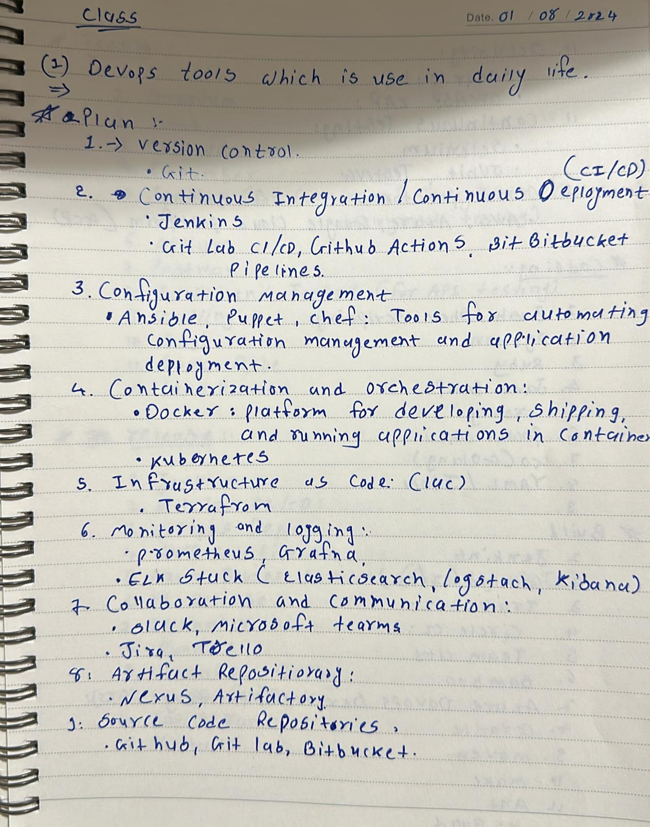

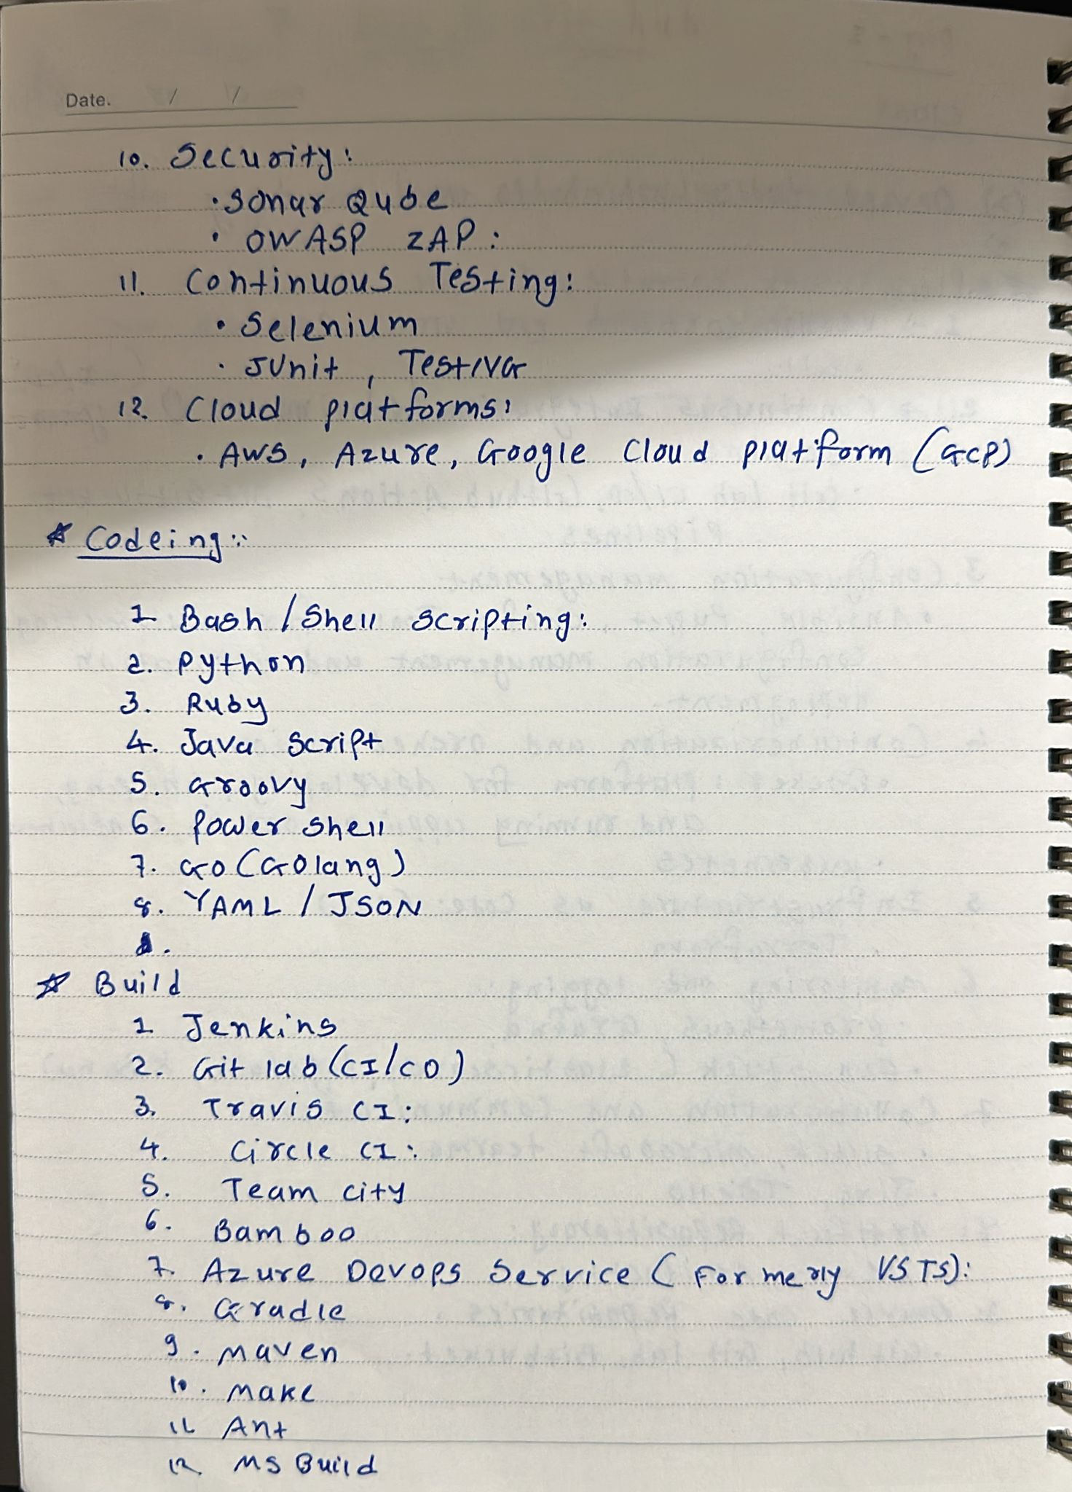

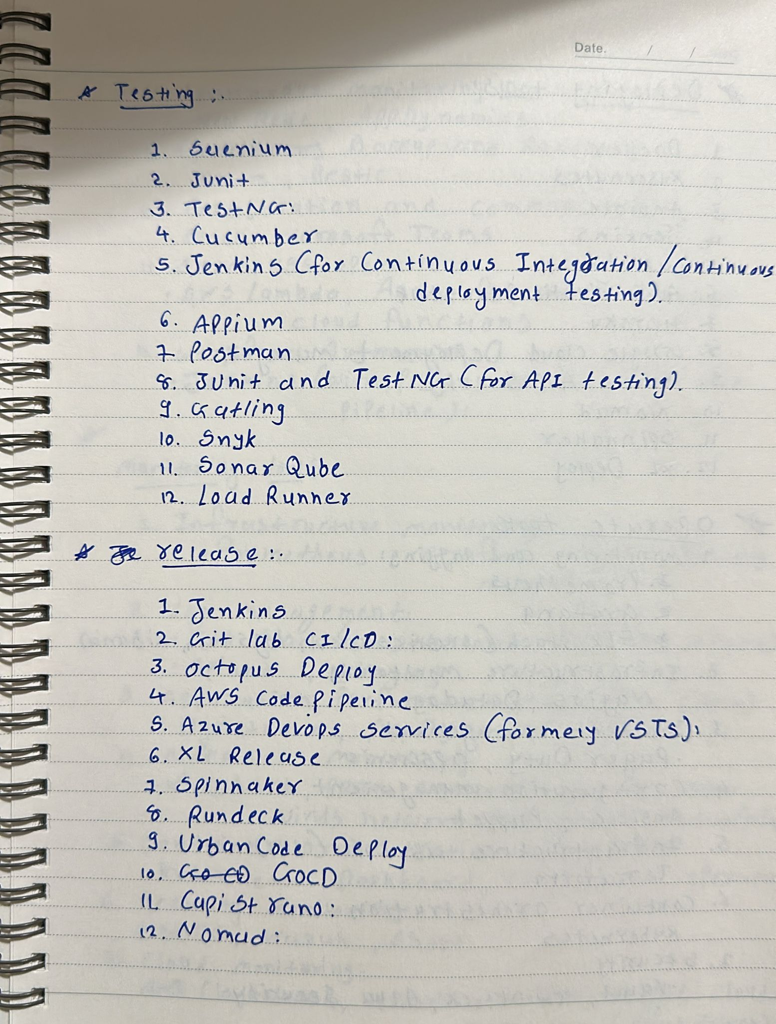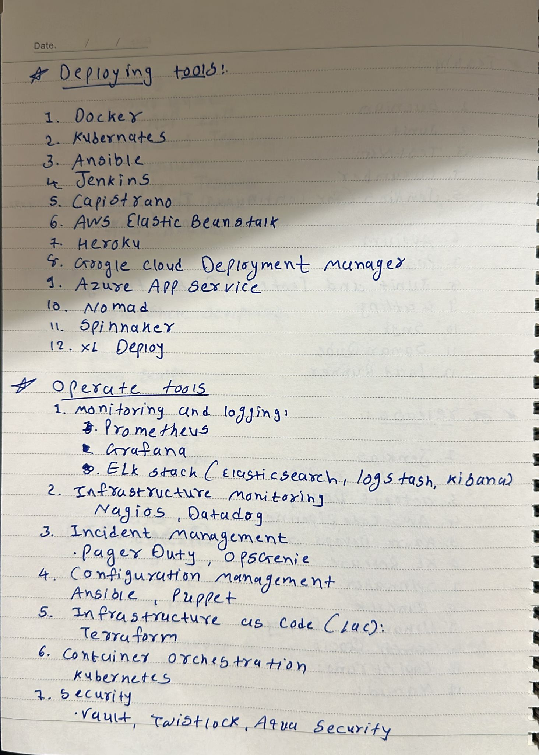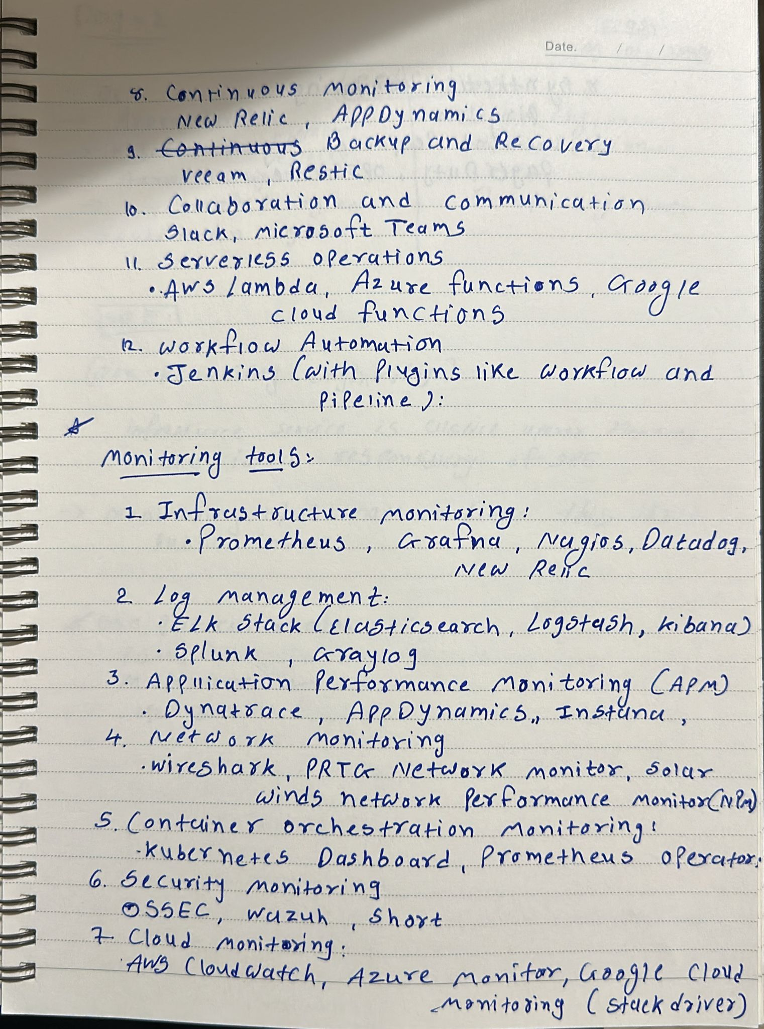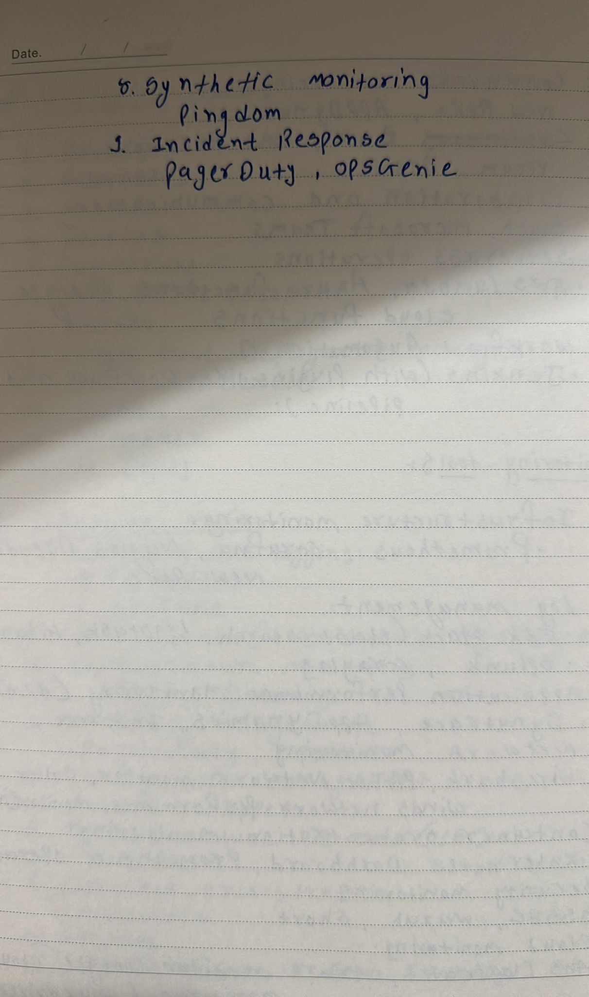2) 2 ) 2) Create AWS Account

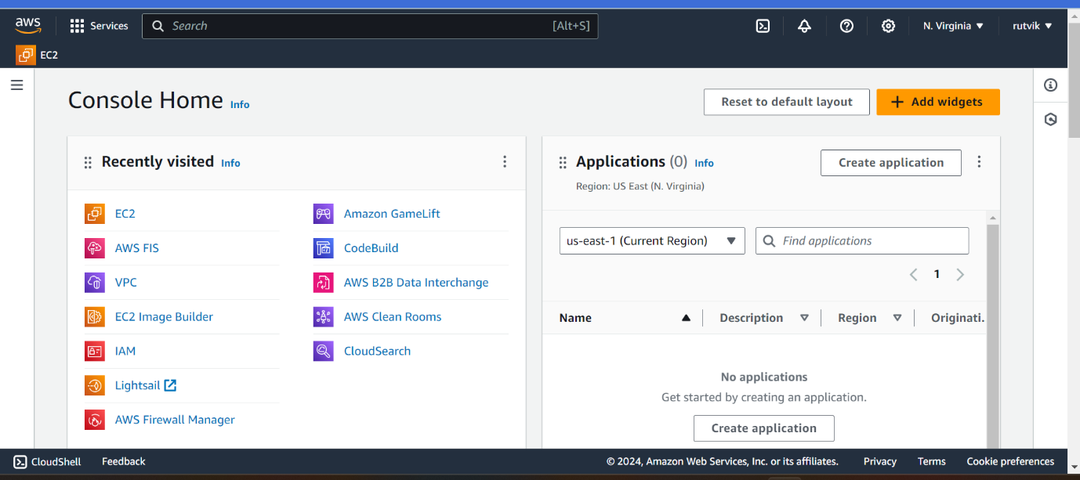

3) Install VS Code

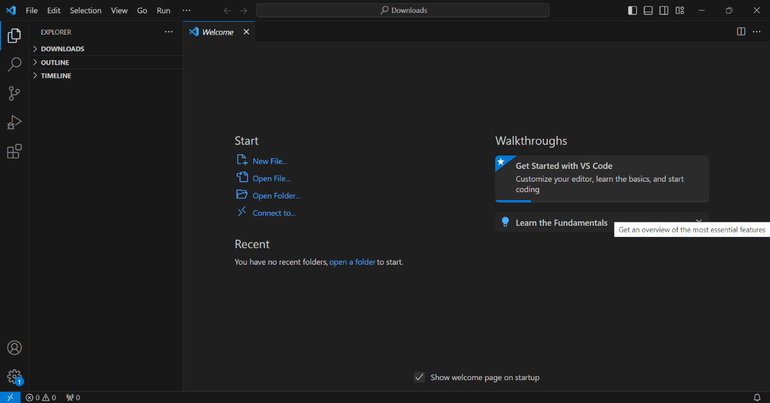

**01/09/2024:** Intro to Cloud

1. Create EC2 in AWS Account

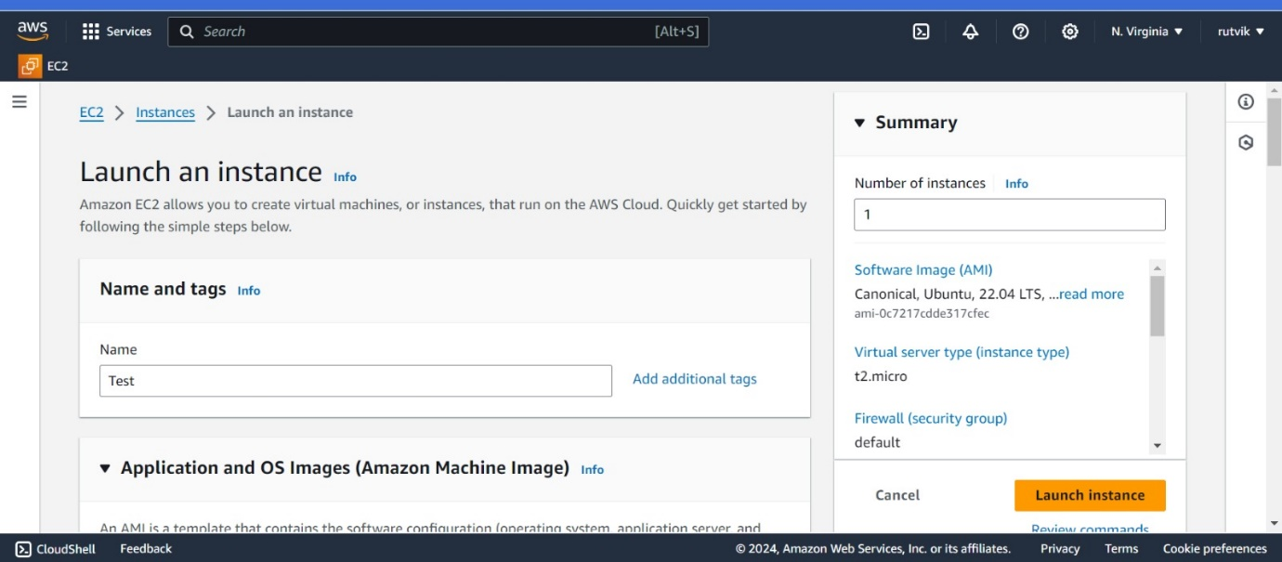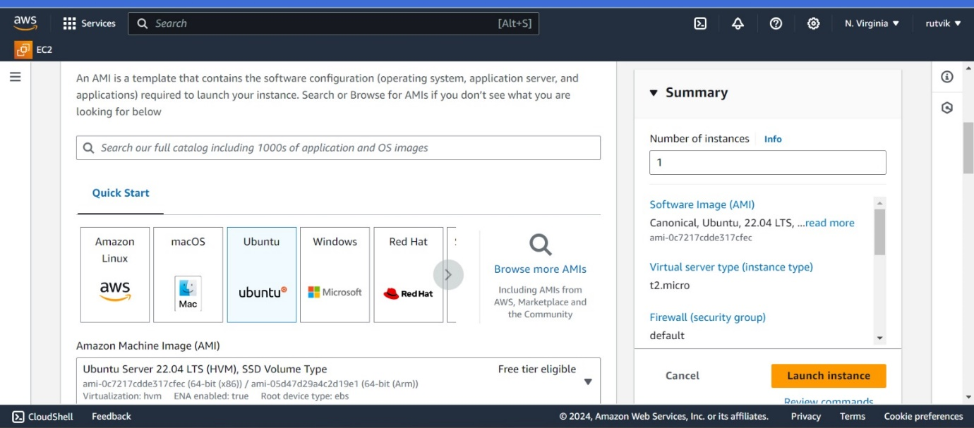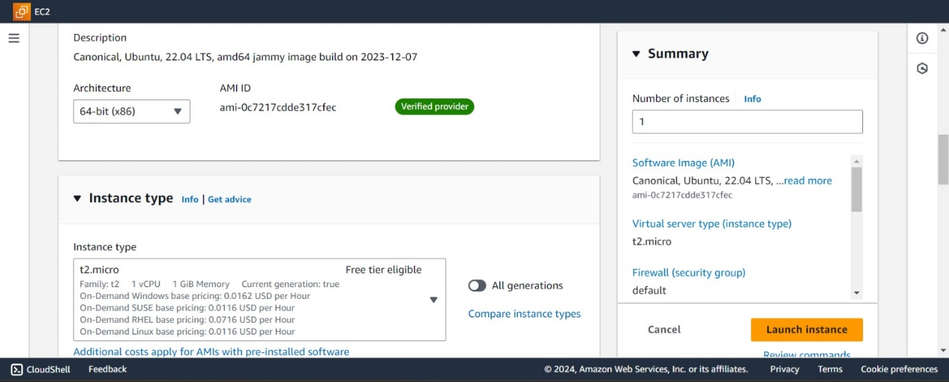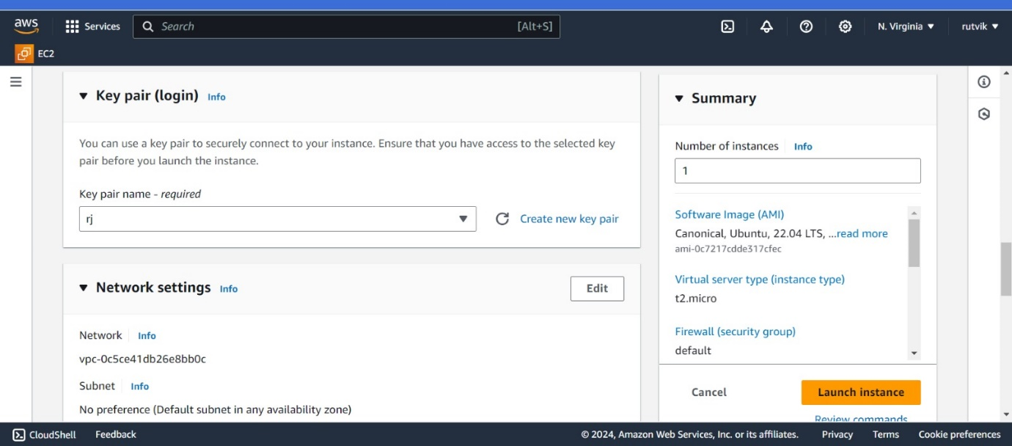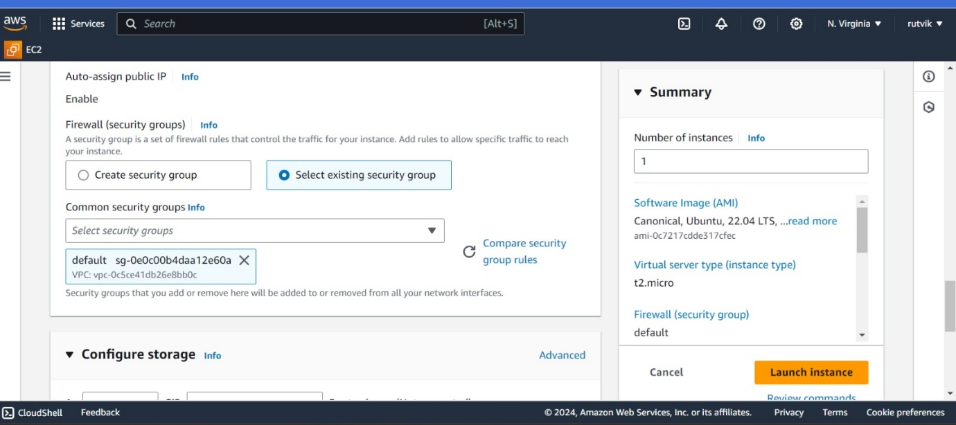 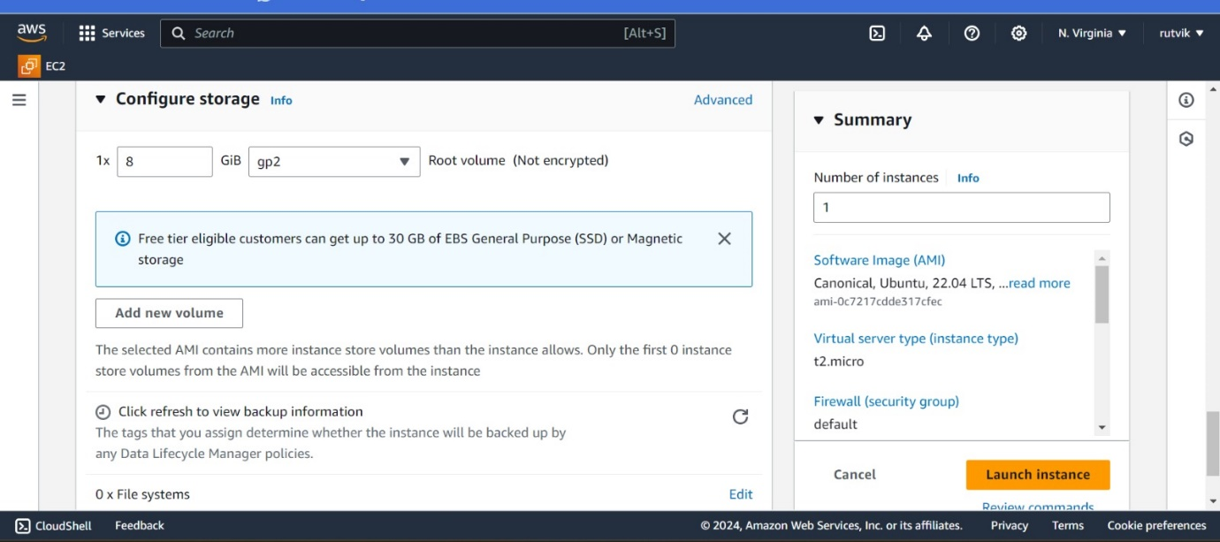

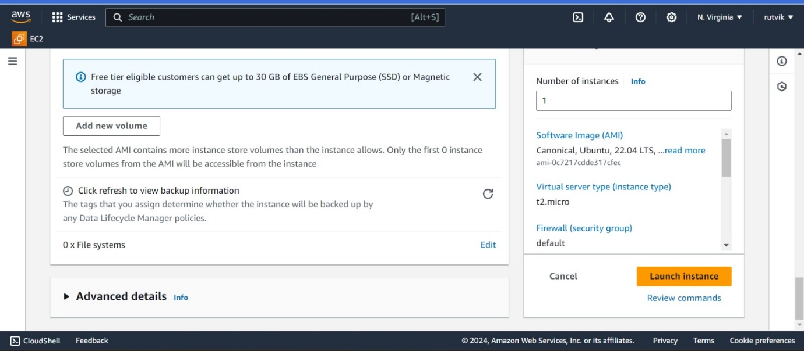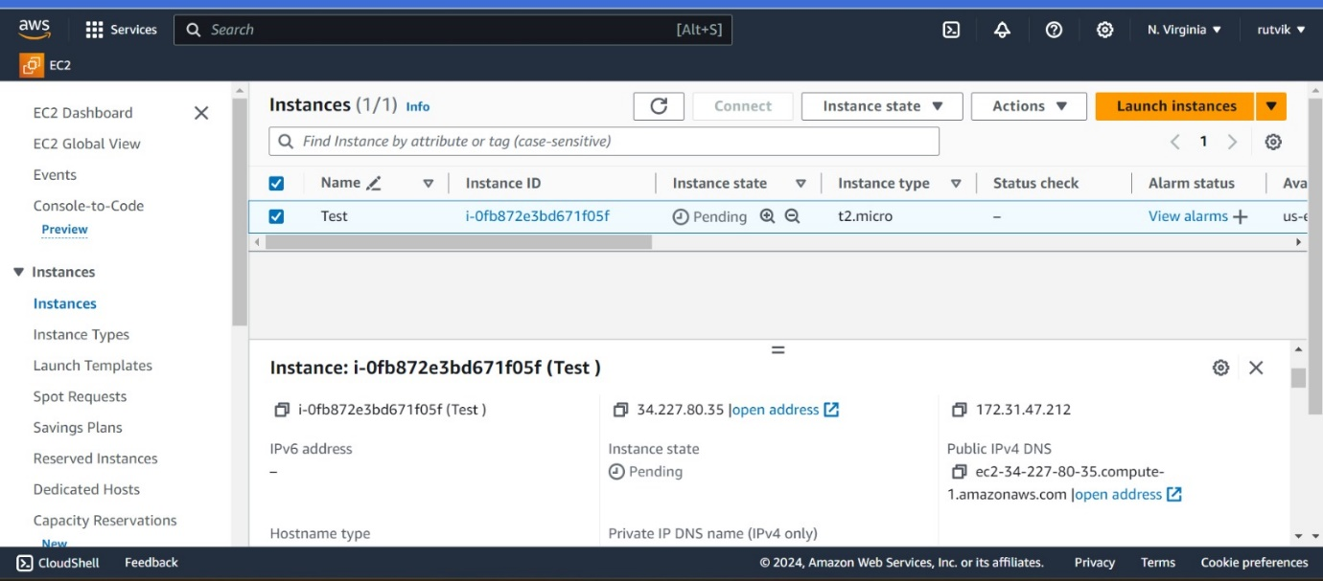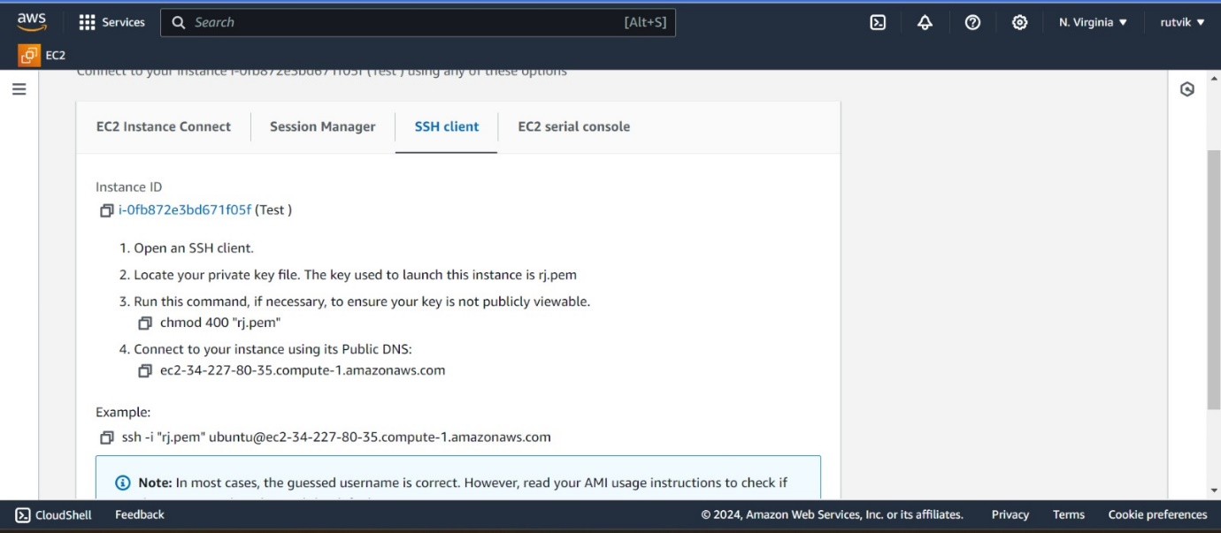

1. Connect to Linux EC2 from local Machine

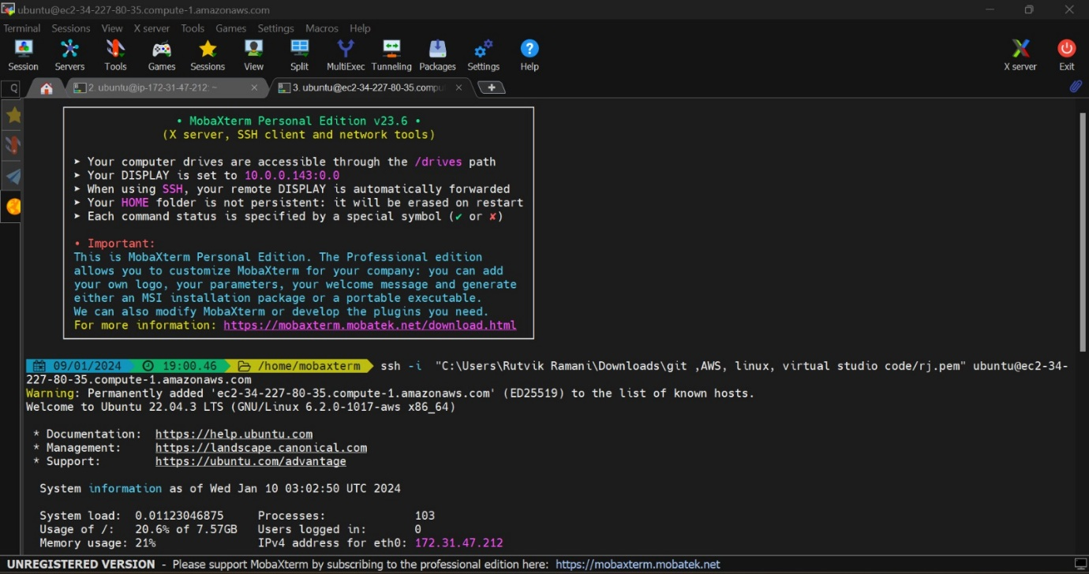

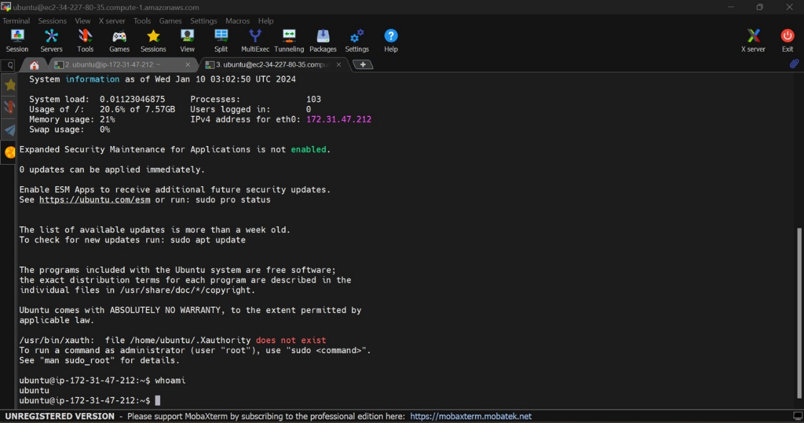

**01/10/2024 :** Intro to Network Agile

1. Understand and Create VPC

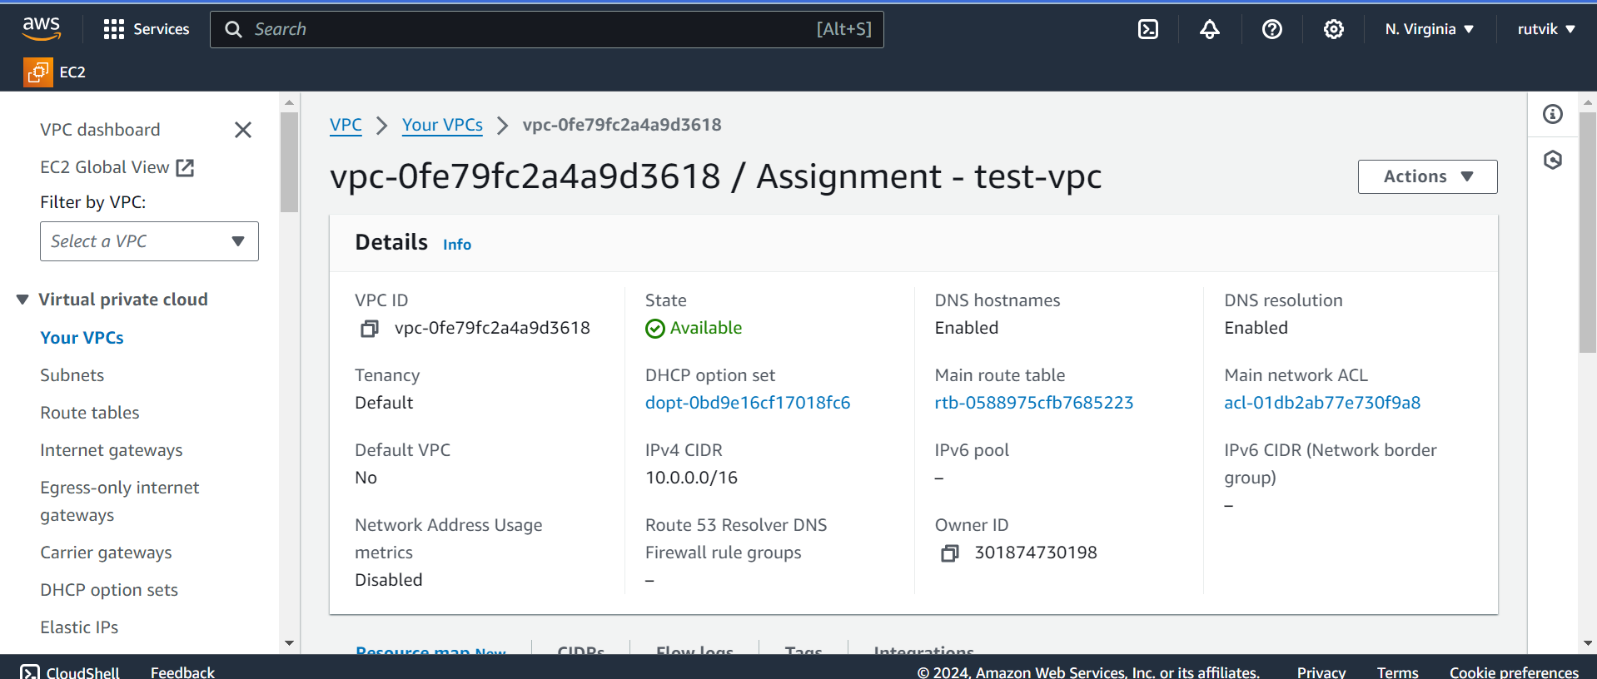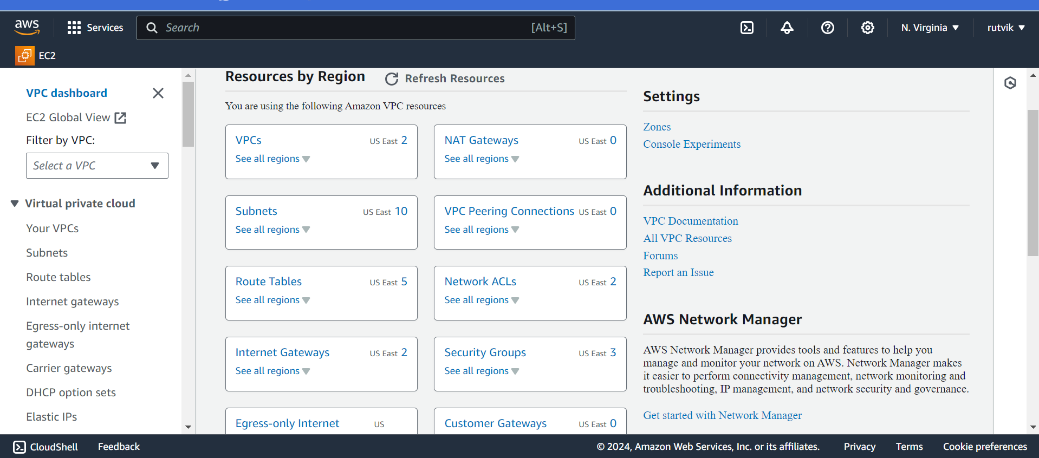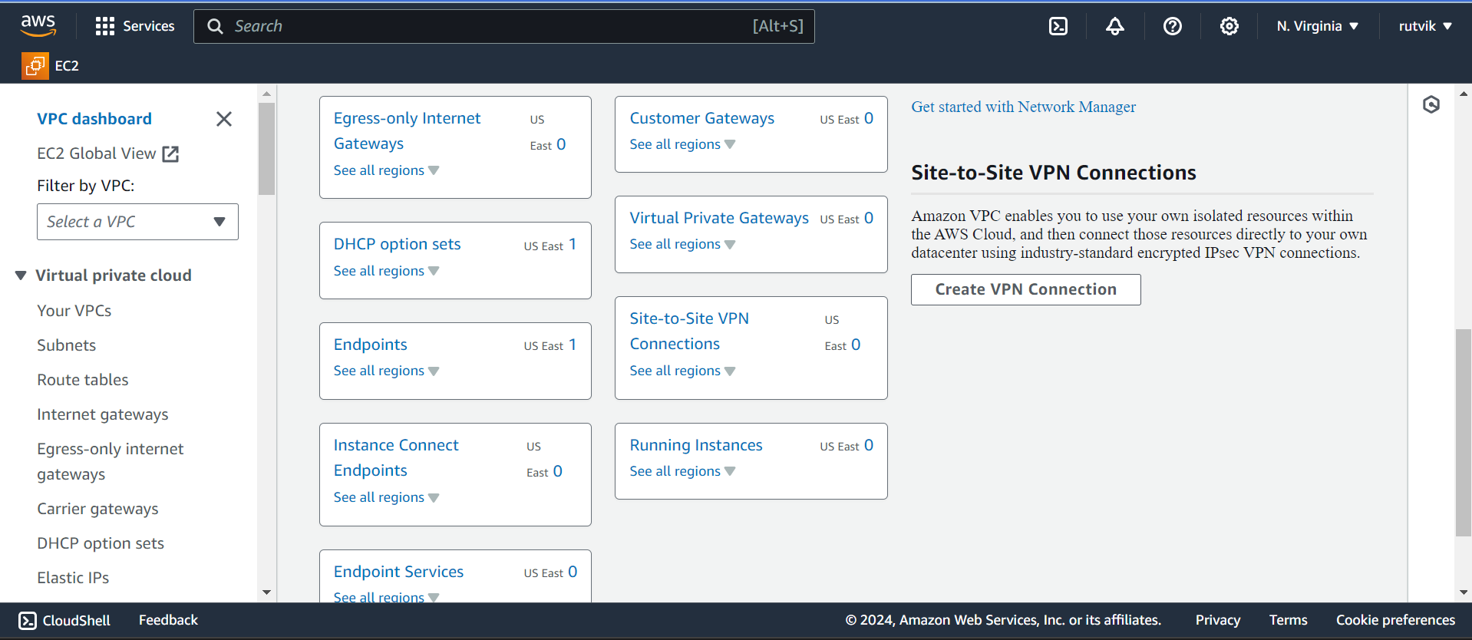

**01/11/2024 :** Networking

Create Disaster Recovery Diagram for EC2

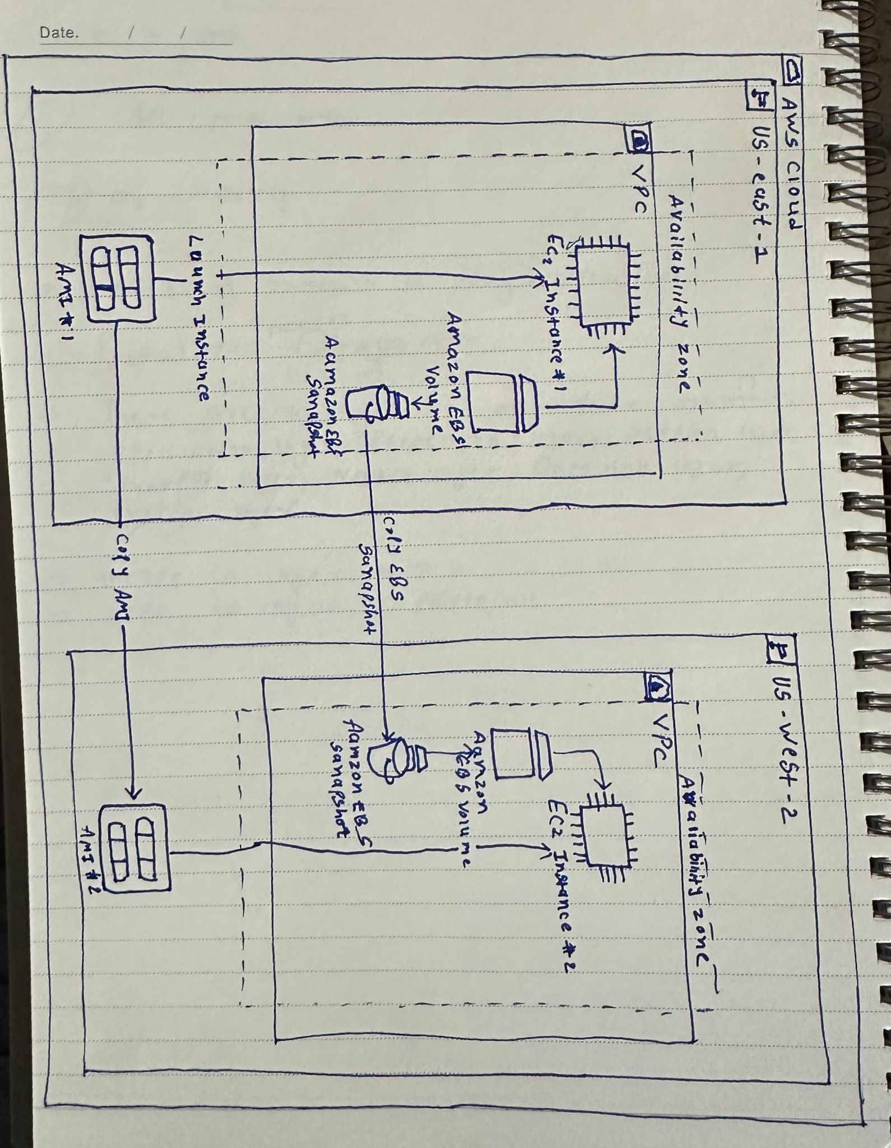

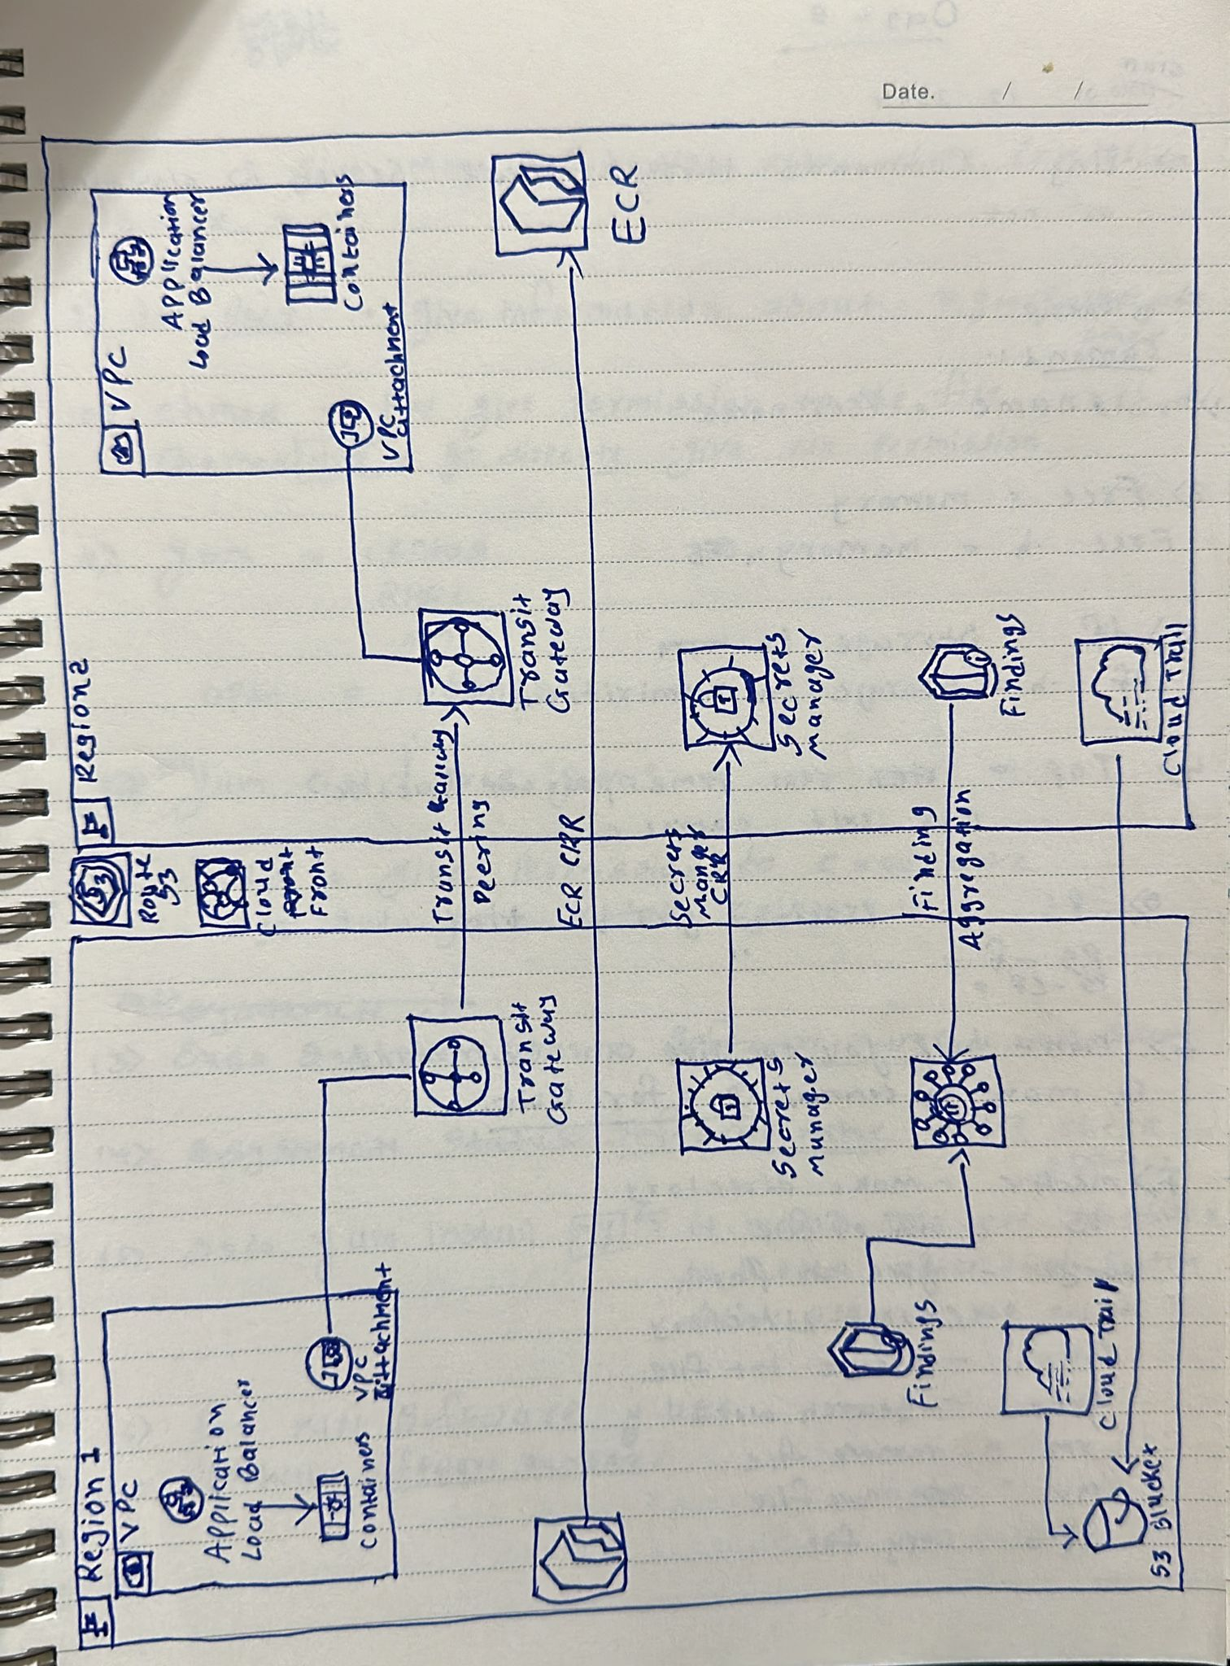

**01/12/2024 : linux**

1. Find all files in entire machine ending with .txt and remove them

For Find : find / -type f -name "*.txt"

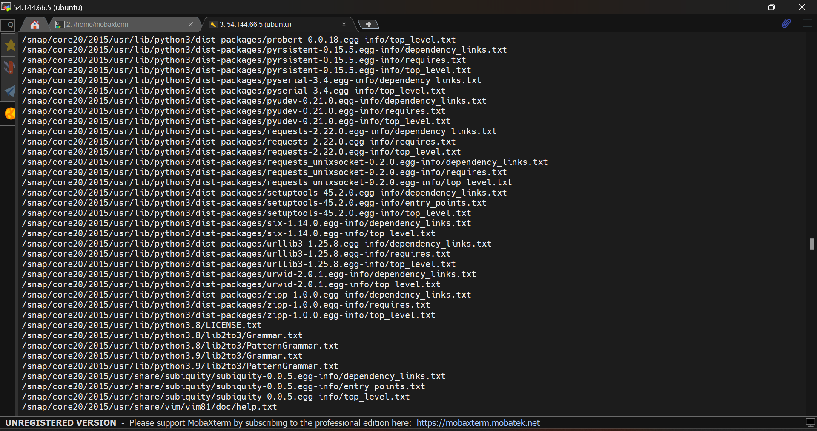

Command : find -type f -name "*.txt" -exec rm {} \;

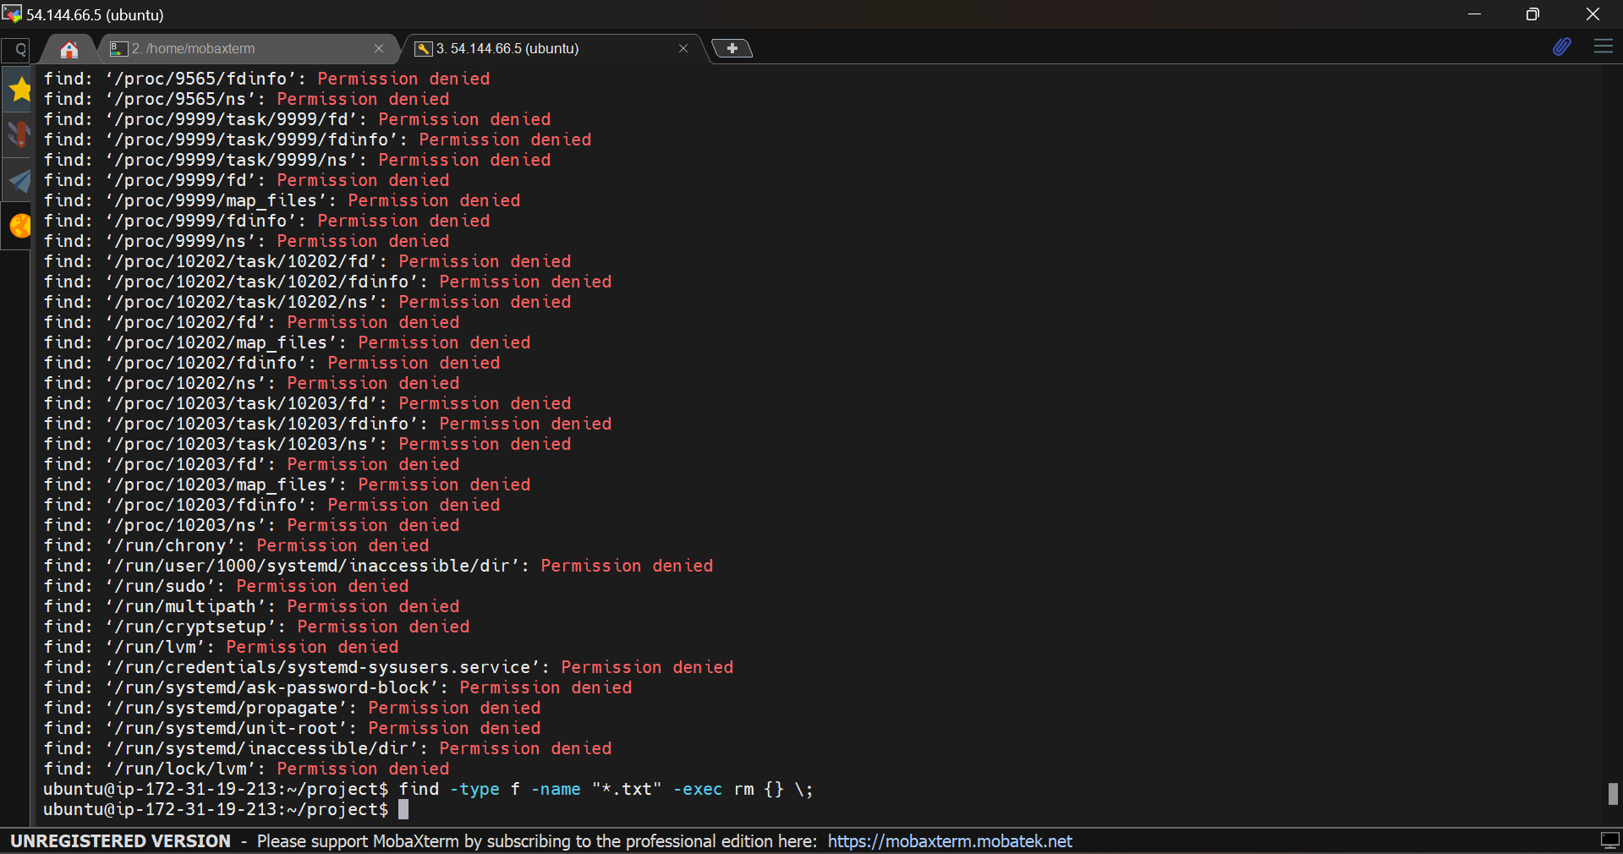

1. Find 10th record of var/log/audit/access.log file

PWD : home/var/log/audit/audit.logs

Give permission by chmod

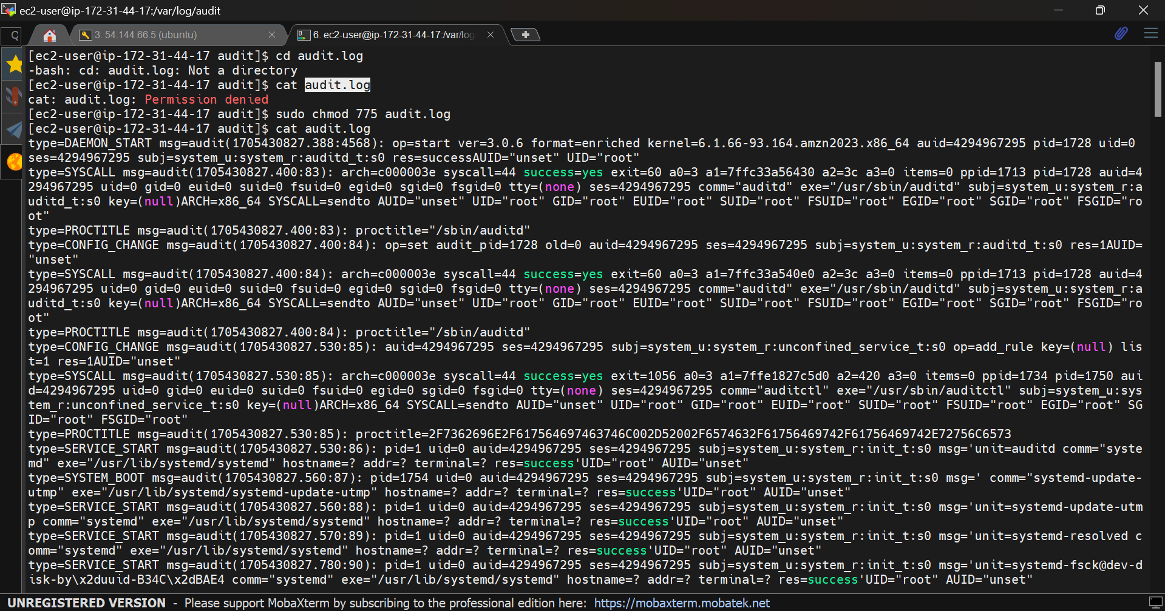

1. Get only todays logs from access.log file

Command: tail -n +10 audit.log | head -n 1

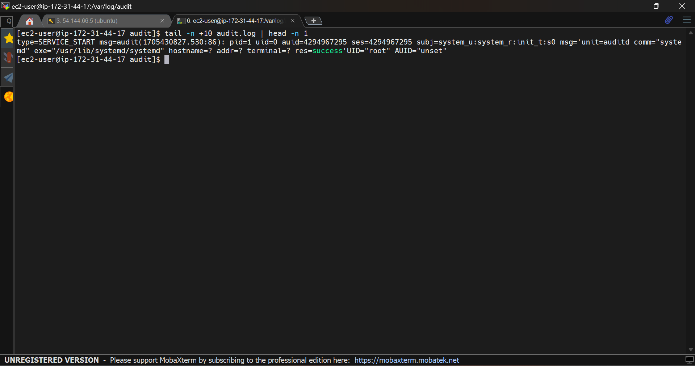

1. Get all ports which are running ( Occupied Ports)

Command : Sudo ss -tuln

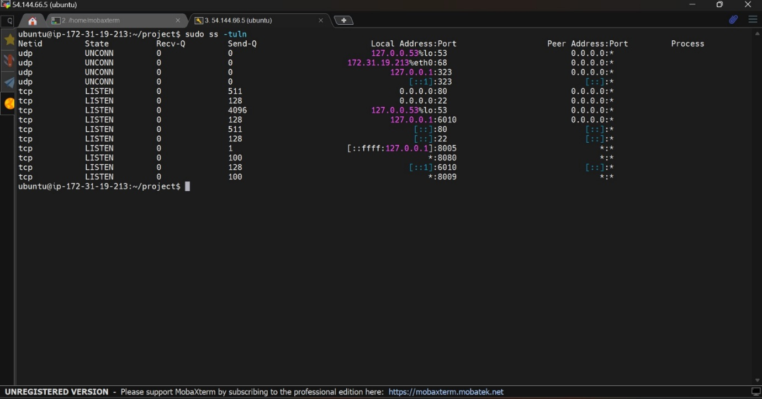

5) Find a file and change permissions

find /path/to/search -name "filename"

find /home/user -name "example.txt"

for permissions : chmod

**01/14/2024:**

1. Create a shell file which includes Installation of Tomcat 9(into new directory) and start tomcat service Execute created shell file which should install and start service

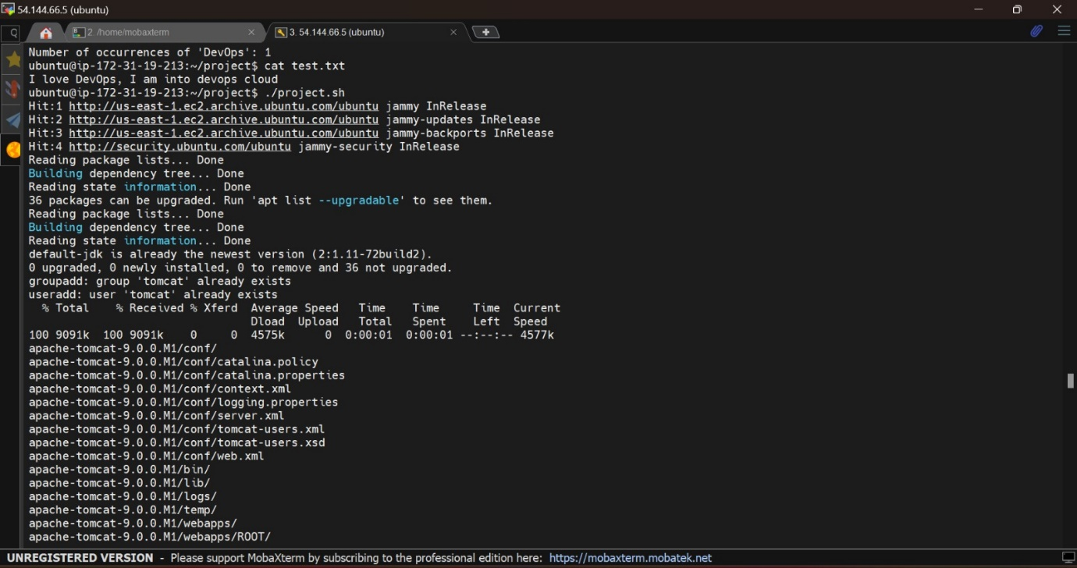

**Note**: Tomcat Requires Java as Pre-requisite and Tomcat runs on Port 8080 by default

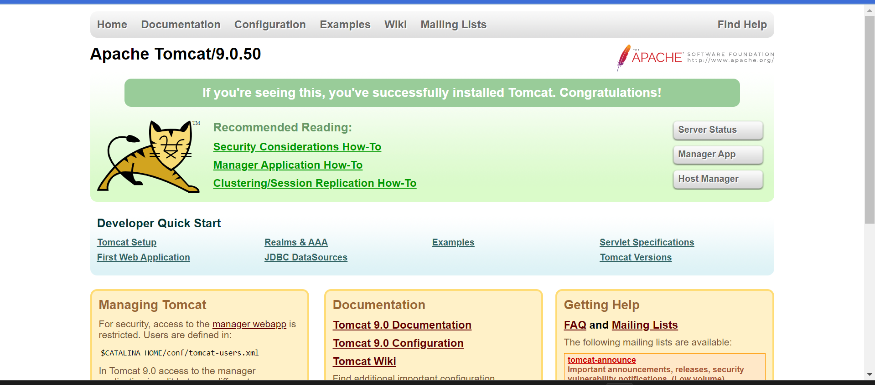

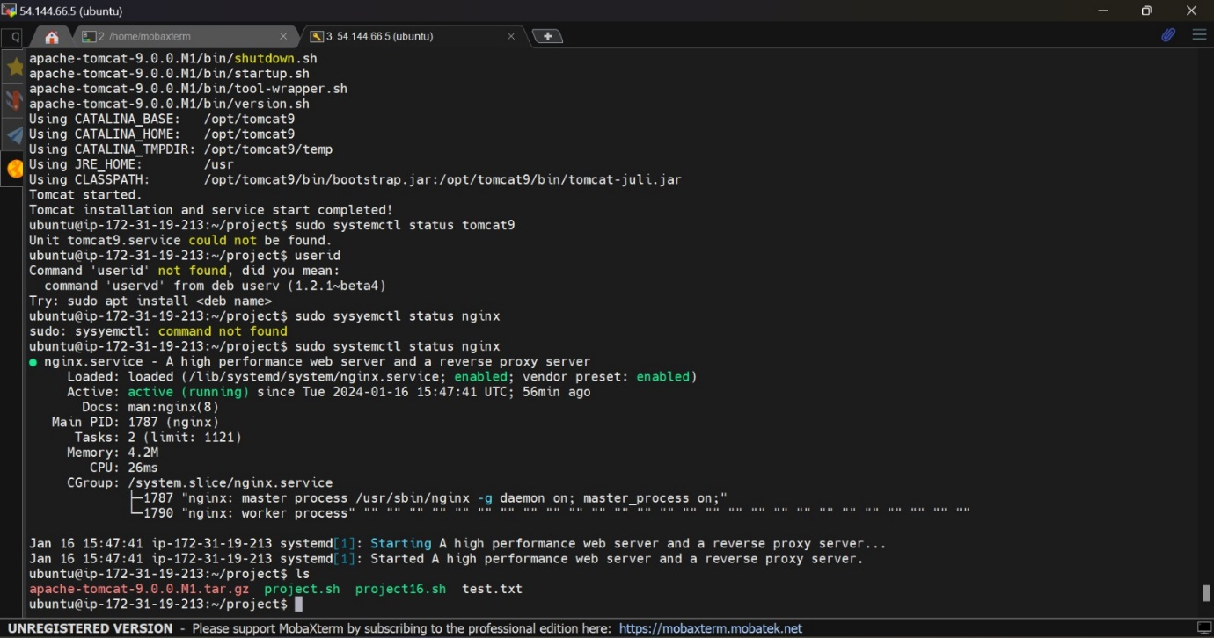2) Create a file (test.txt) with content as ""I love machine, I am into devops cloud"" Write a shell script which has to replace machine into DevOps in above file Then print the no of occurences of devops as output when we execute shell file

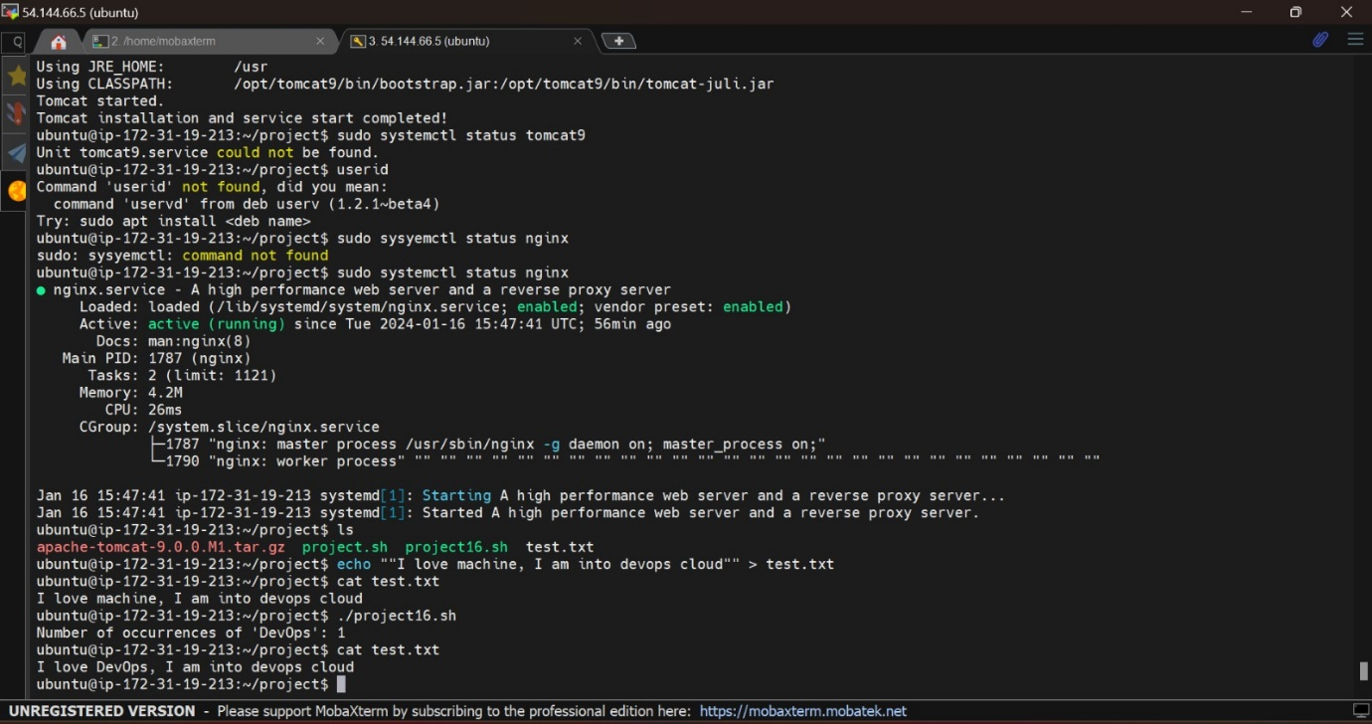

Second way

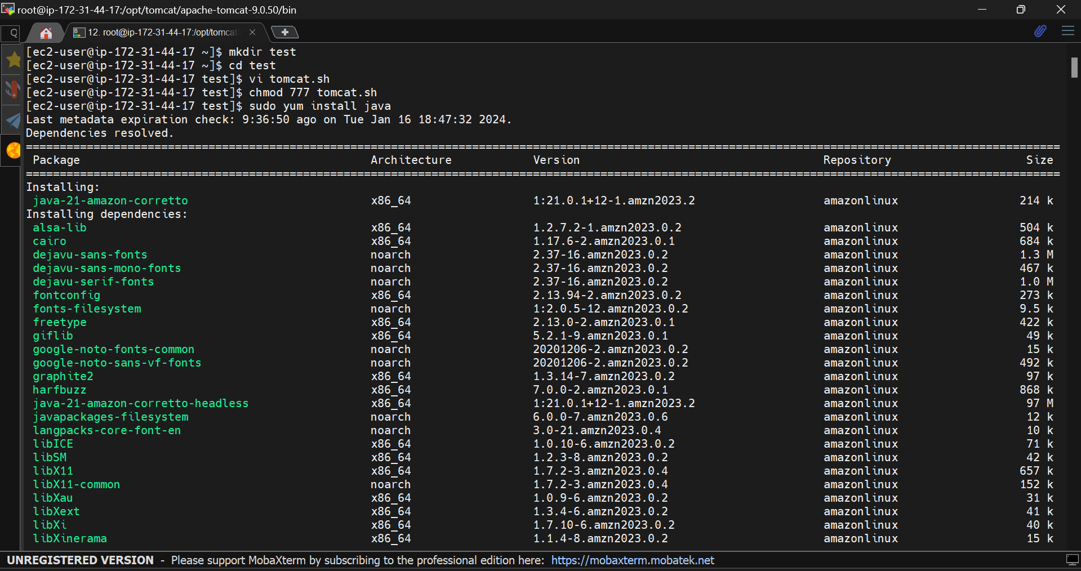

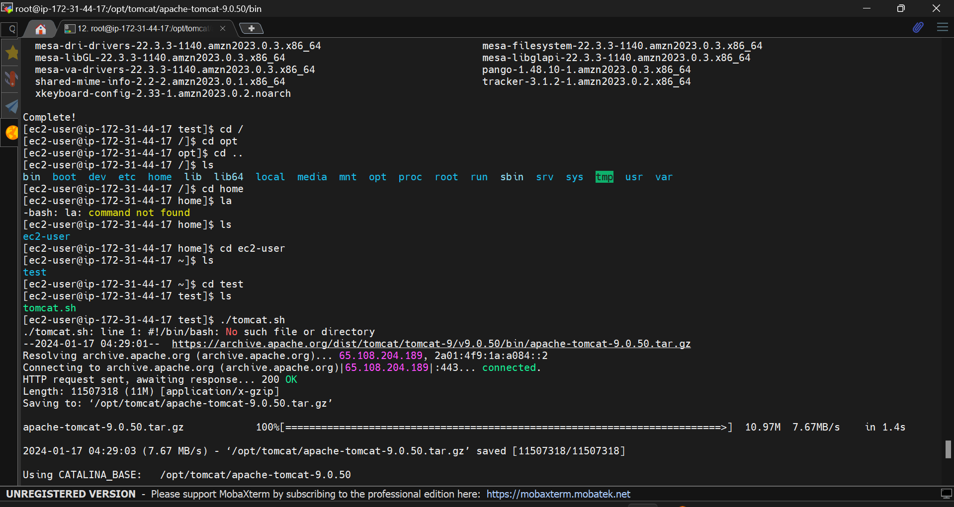

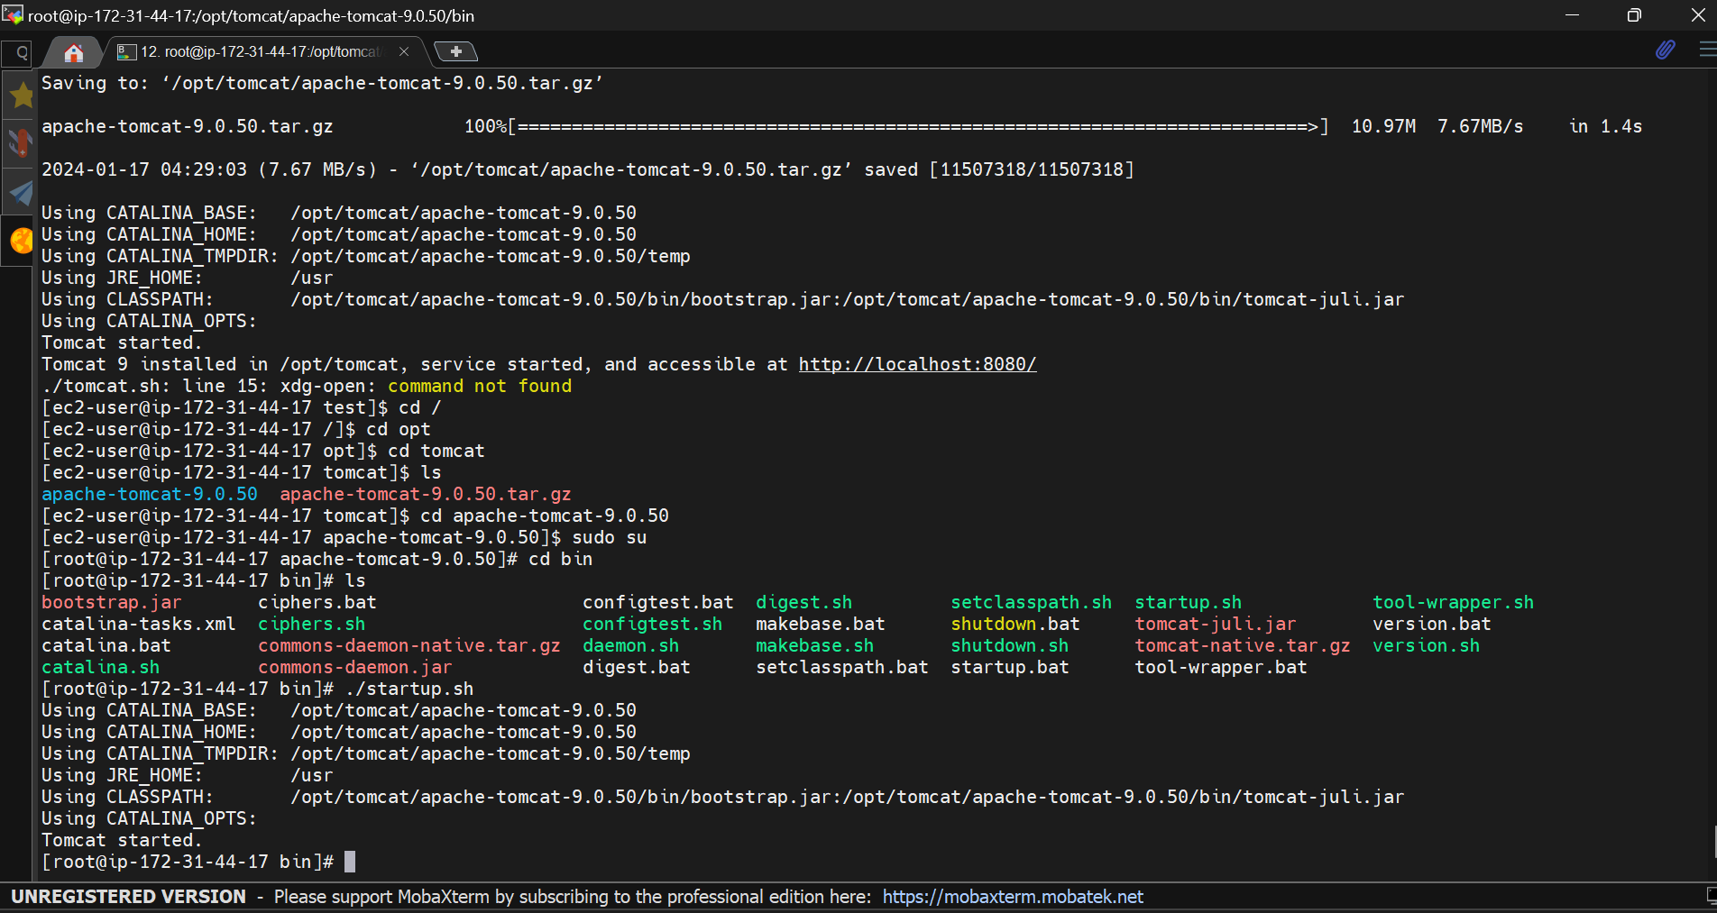

01/15/2024

1. Create ASG with UserData in Launch Template to install nginx and setup min, Desired as 1 and max as 2 with Avg CPU 60



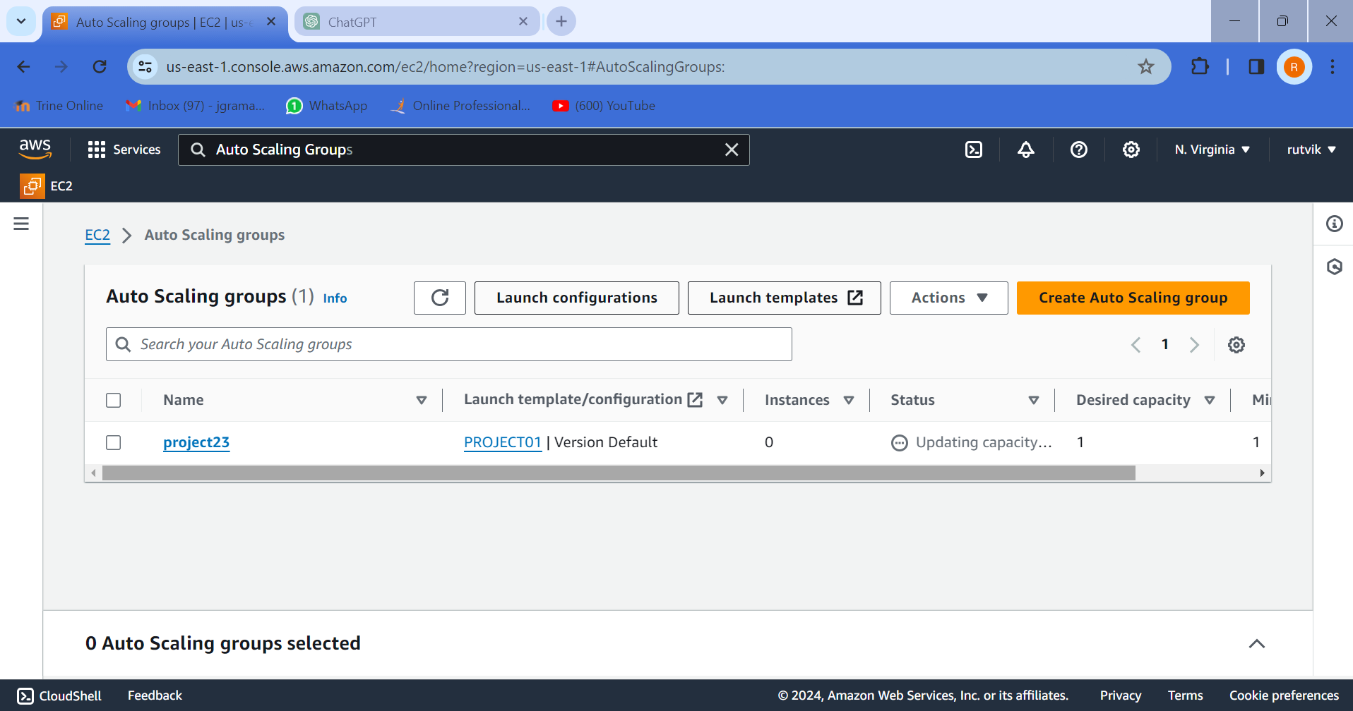

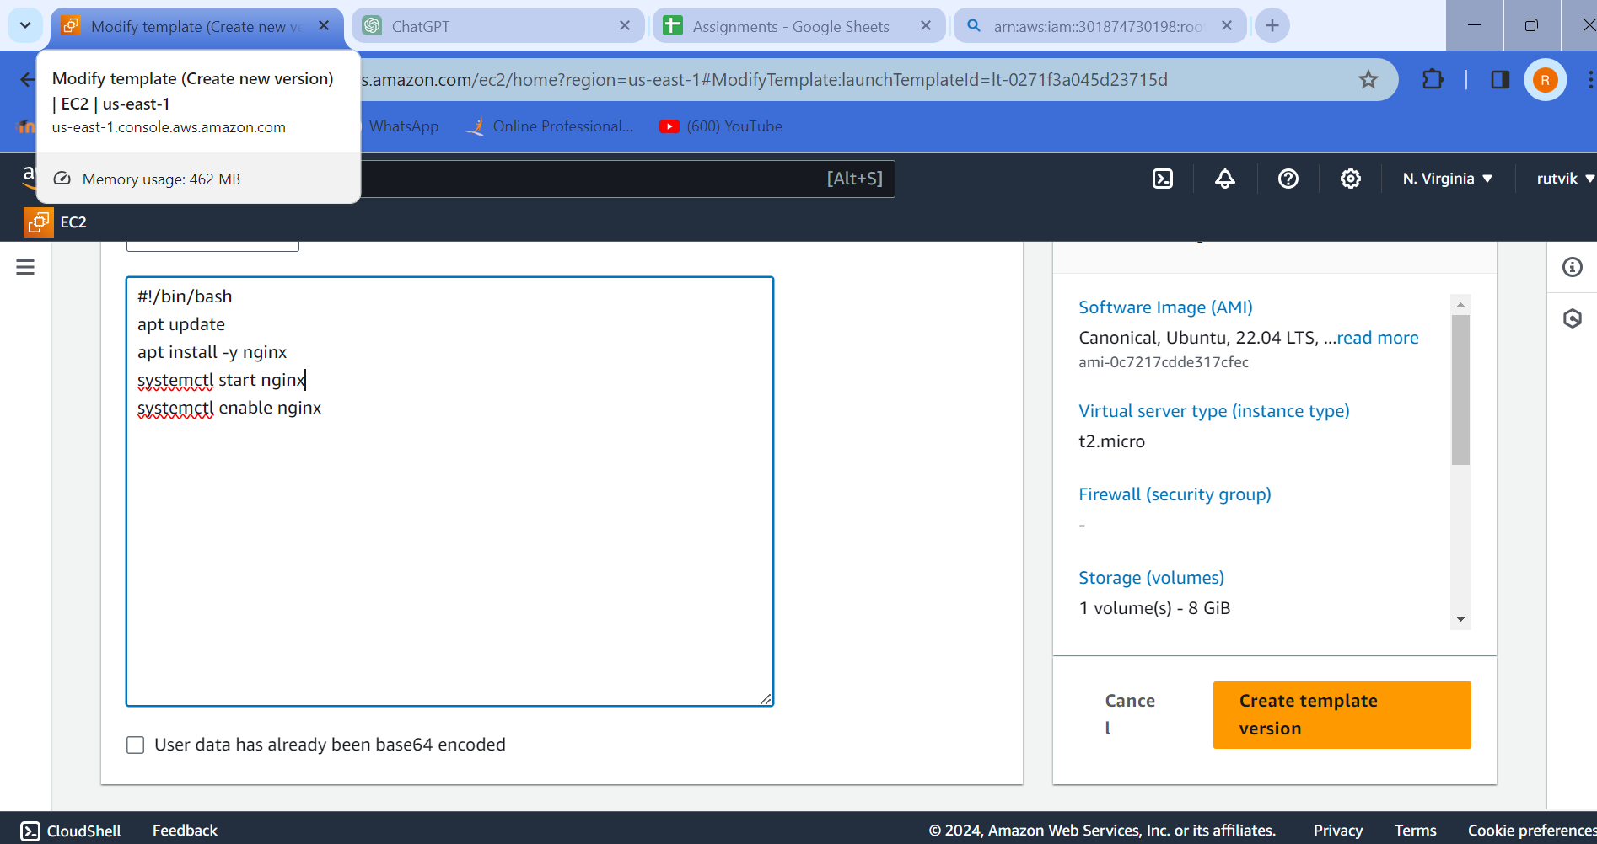

2) Hit ALB DNS and it should distribute traffic to Target Group of Either EC2

3) Download and Install GIT

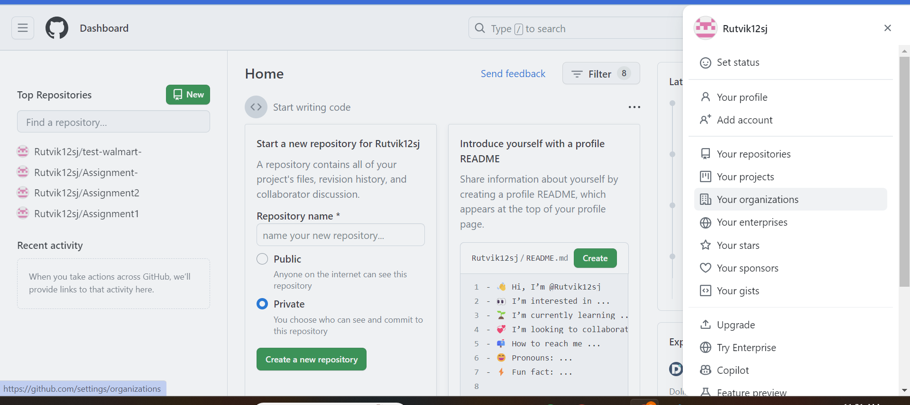

4) Create github account with personal Gmail: [rutvikramani127@gmail.com](mailto:rutvikramani127@gmail.com)

**01/16/2024 : ELB**

Extend Diagram designed on 1/11/24 as above to include ELB and ASG

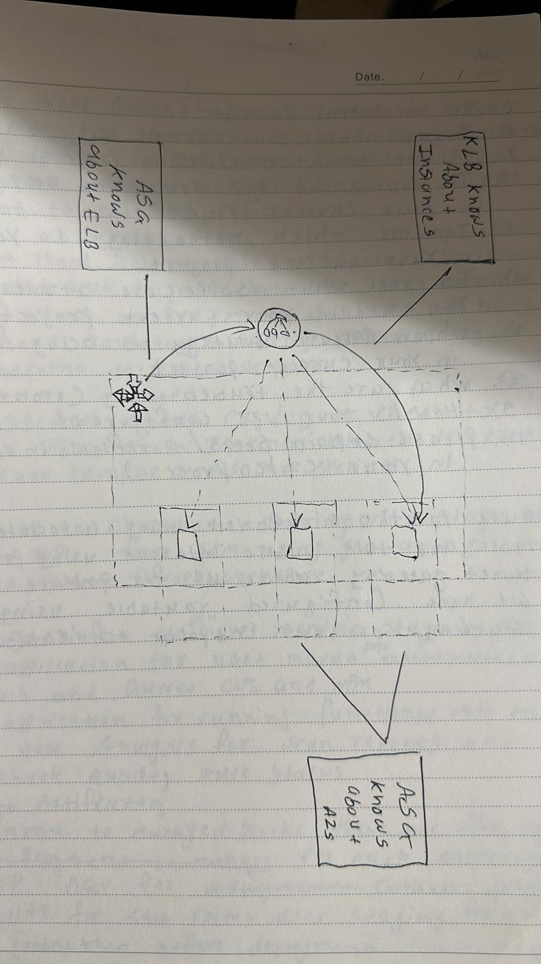

**01/17/2024:** Marketing Questions

Marketing First 5 Questions

**01/18/2024:** Git & Github

Branching Strategy Diagram and Entire Flow

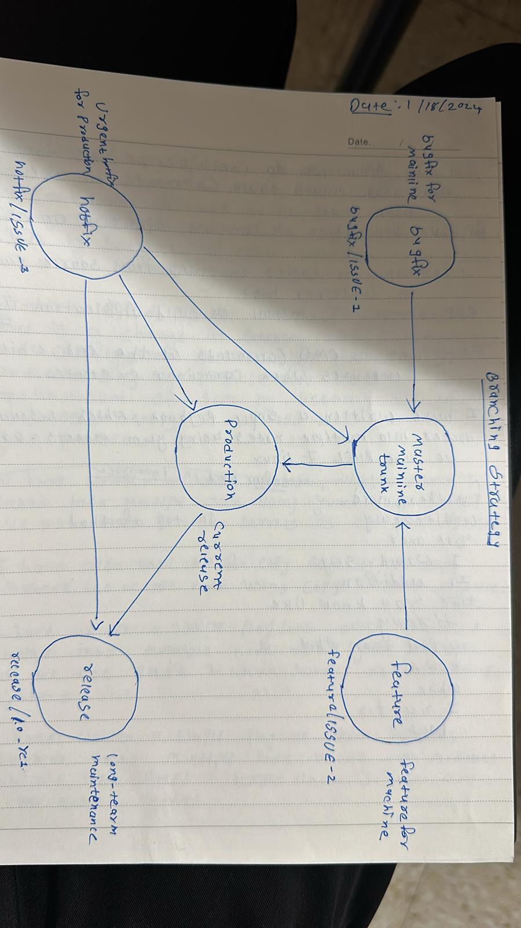

**01/19/2024:** GIT and GitHub

1. create Repo, Clone to Local

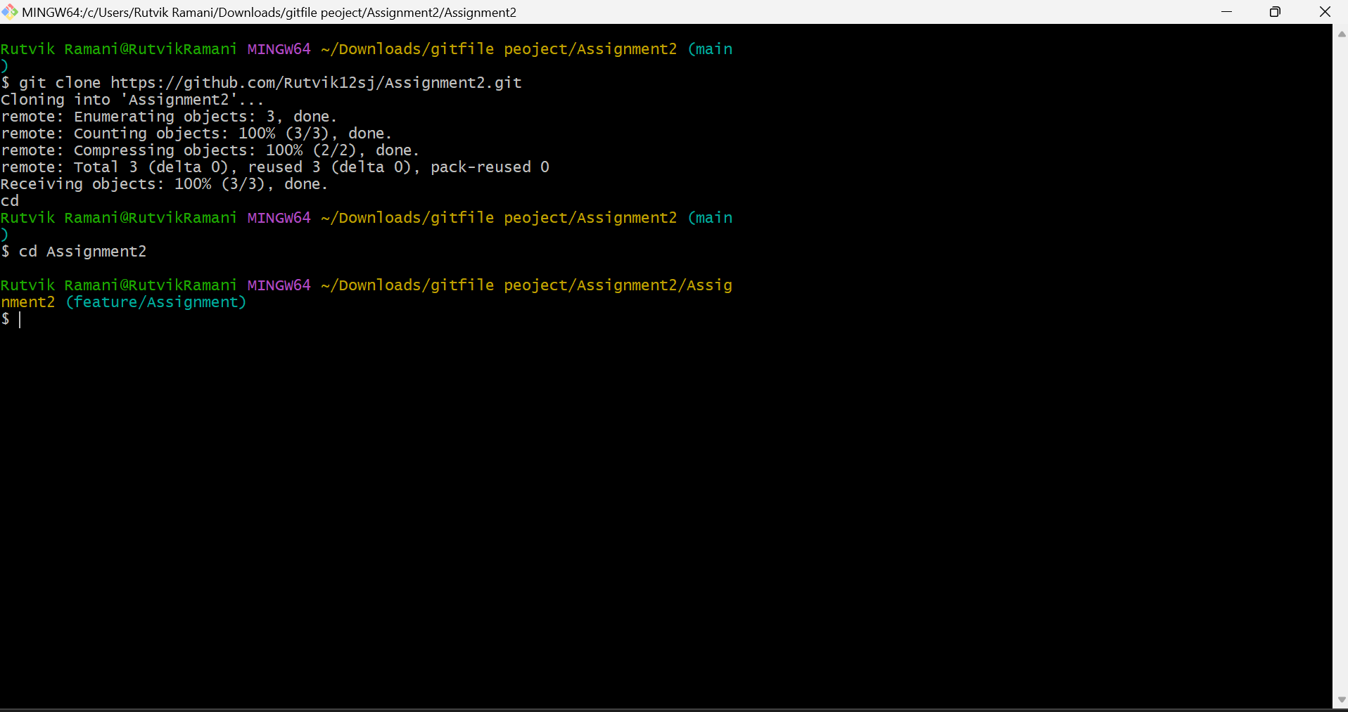

1. Work on 2 Branches and Merge both Branches to develop using PR

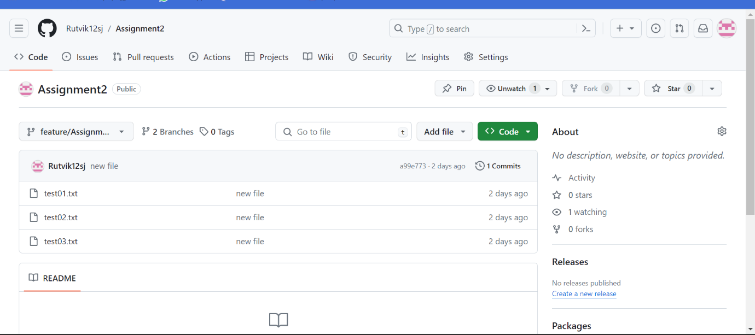

**01/22/2024:**

1. Create Merge Conflict Scenario and resolve Merge Conflicts with 2 branches changed using same file

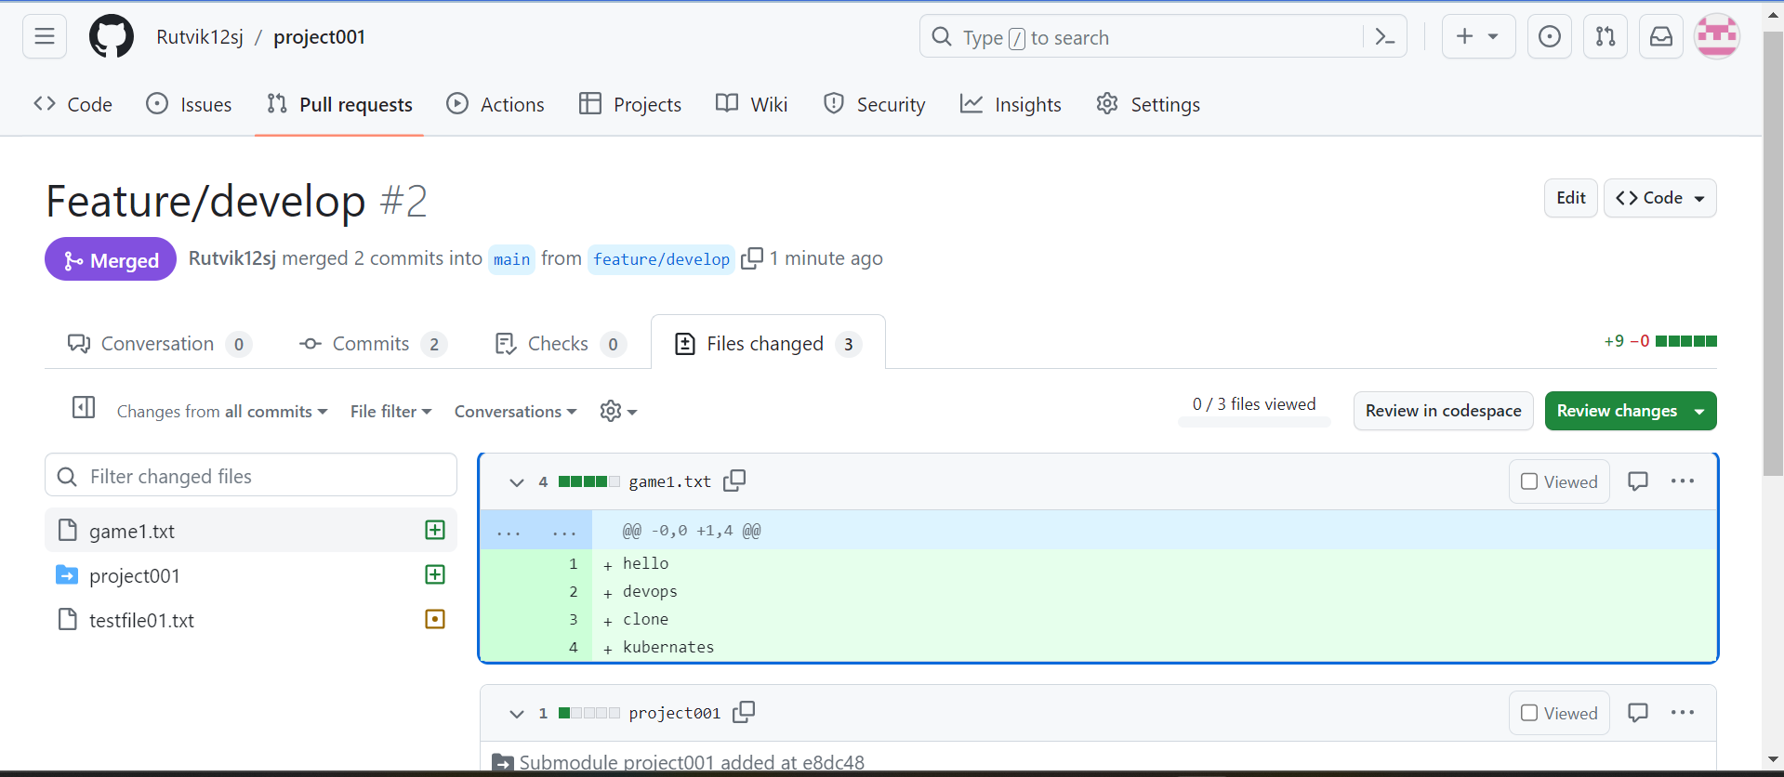

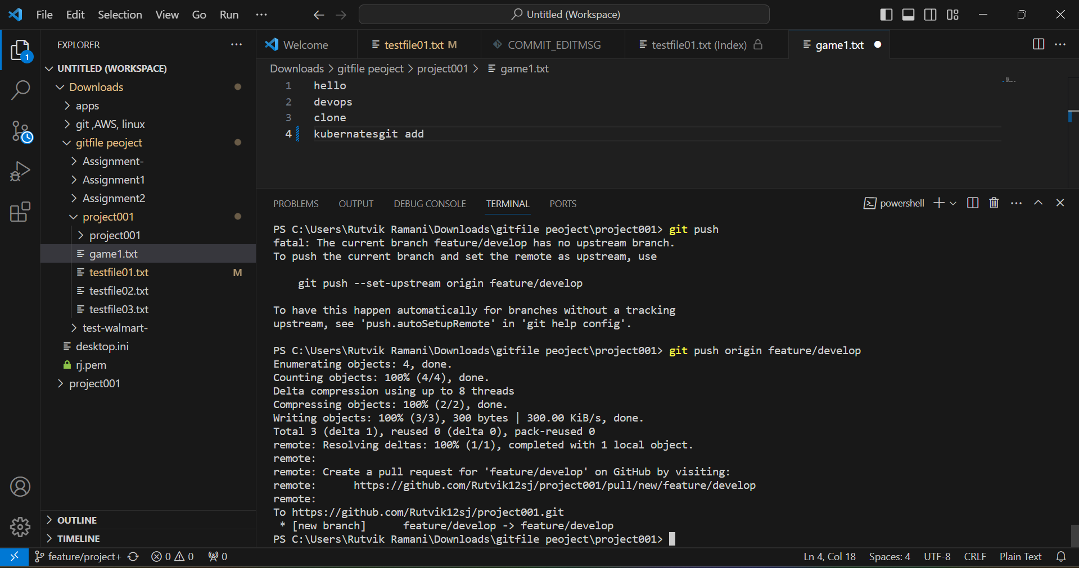

2) Merge vs rebase (observer commit log)

3) git pull vs fetch

**Git fetch vs git pull**

When we do git pullit automatically merges the commits **without reviewing them unless merge conflicts arises.**

**When we do git fetch => It doesn’t get files transferred, it just checks if there are new changes.**

**Git merge vs git rebase**

Merging preserves the entire history of your repository by creating new commit, while rebasing creates a linear history by moving your feature branch onto the tip of main

**01/23/2024: CI/CD Intro**

1. Create Jenkinsfile and Promote through Branching Strategy

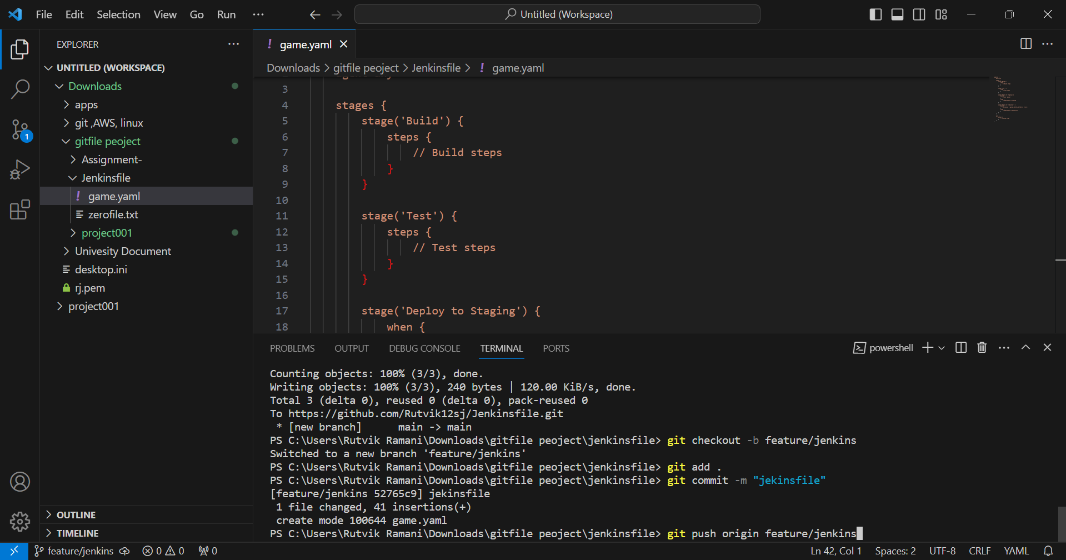

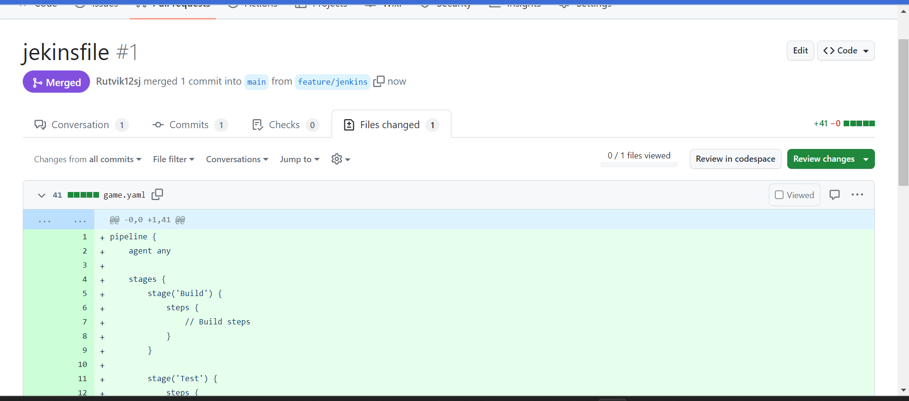2) Install Jenkins in Ubuntu EC2

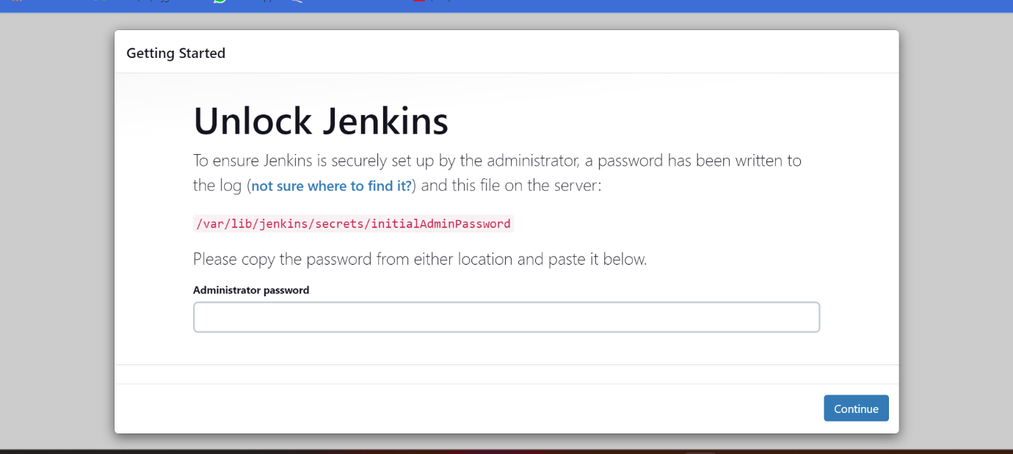

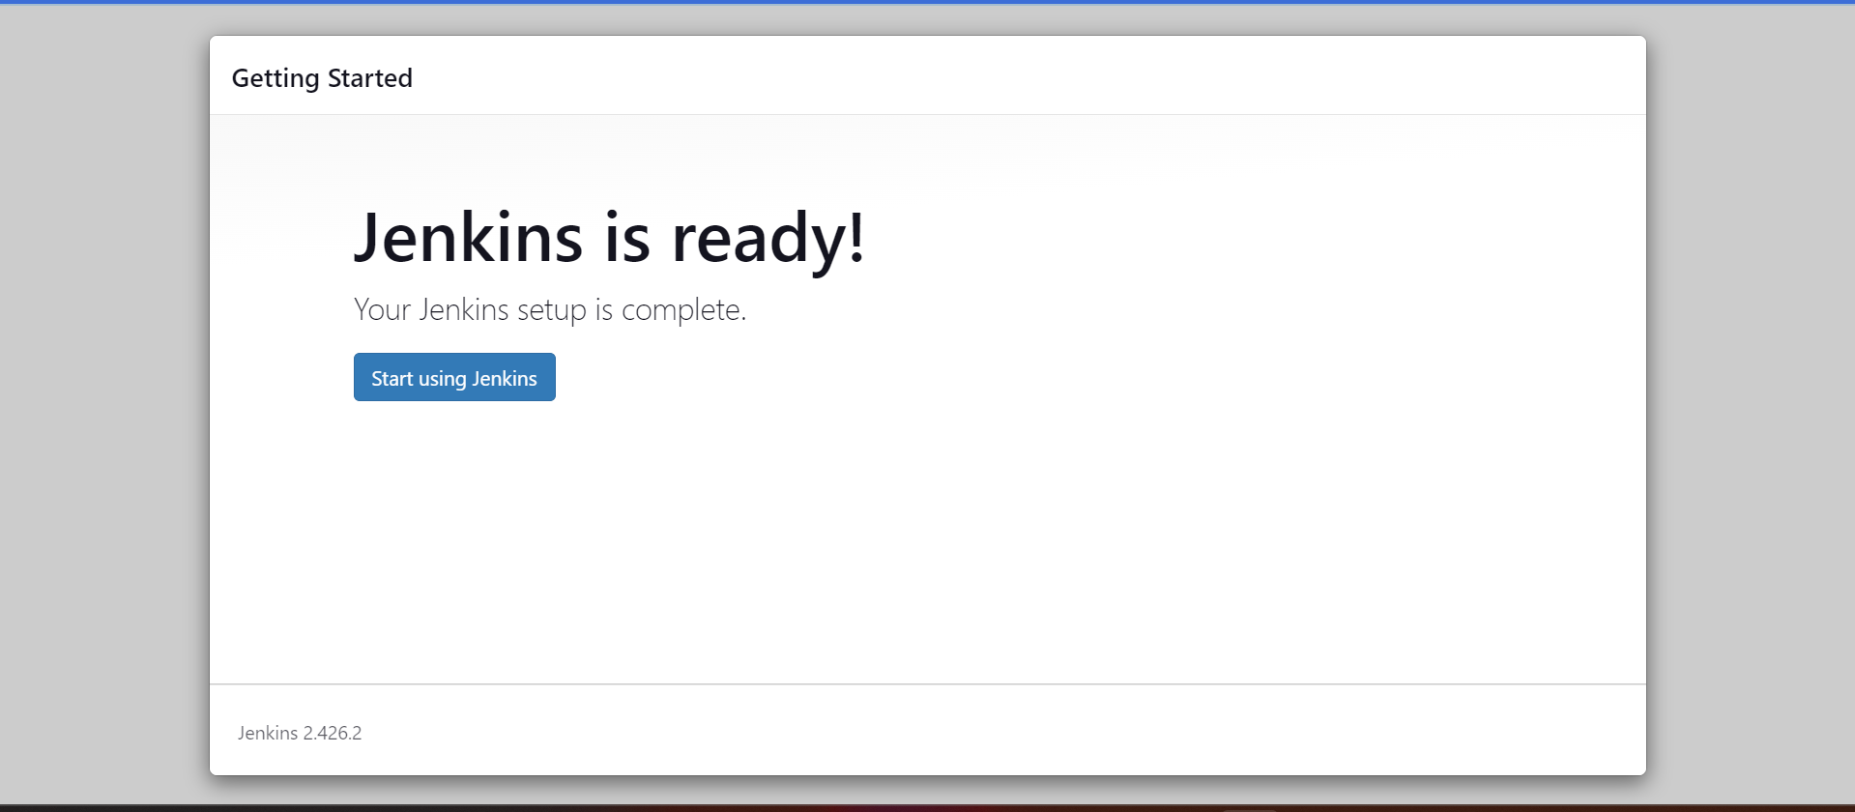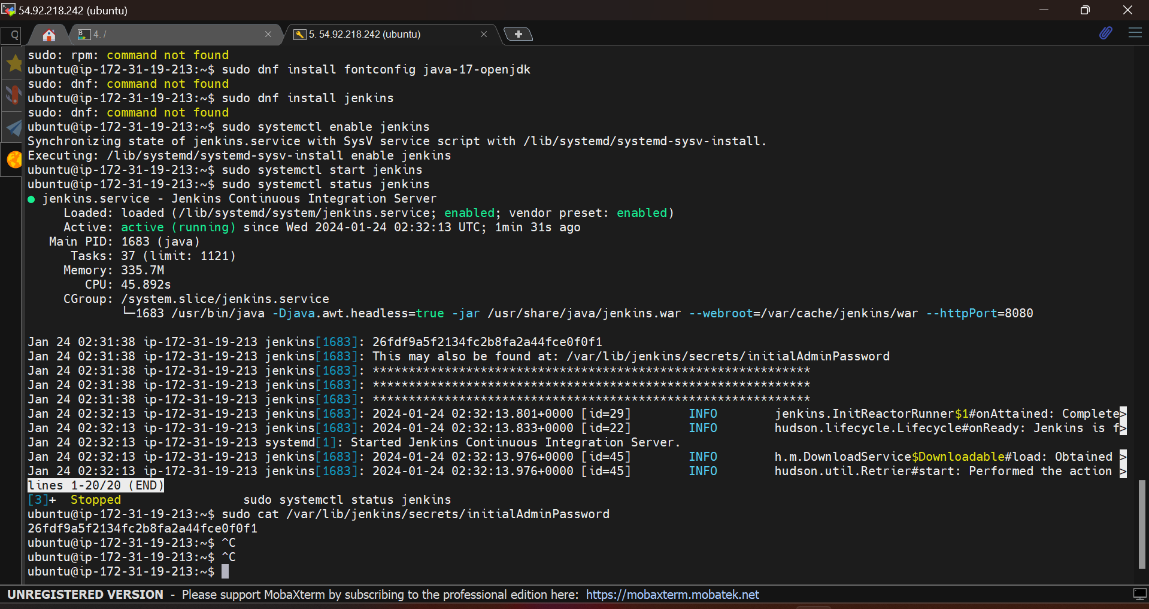

**01/24/2024 :** CICD Setup and Pipeline

1) Create Multi Branch Pipeline in Jenkins Server (Configure Git URL of previous task with credentials)

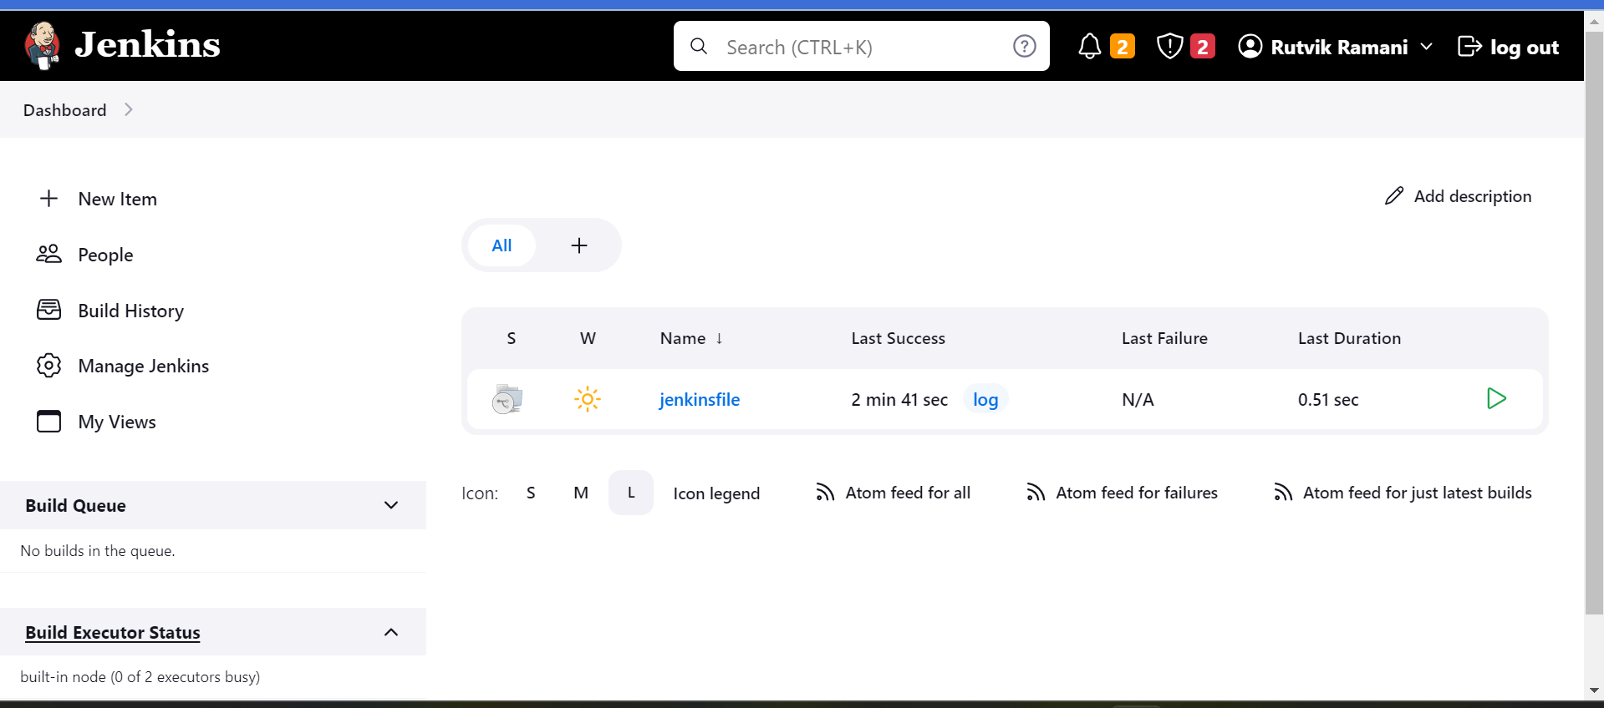2) Have that Jenkinsfile with sample structure from Previous task and run pipeline

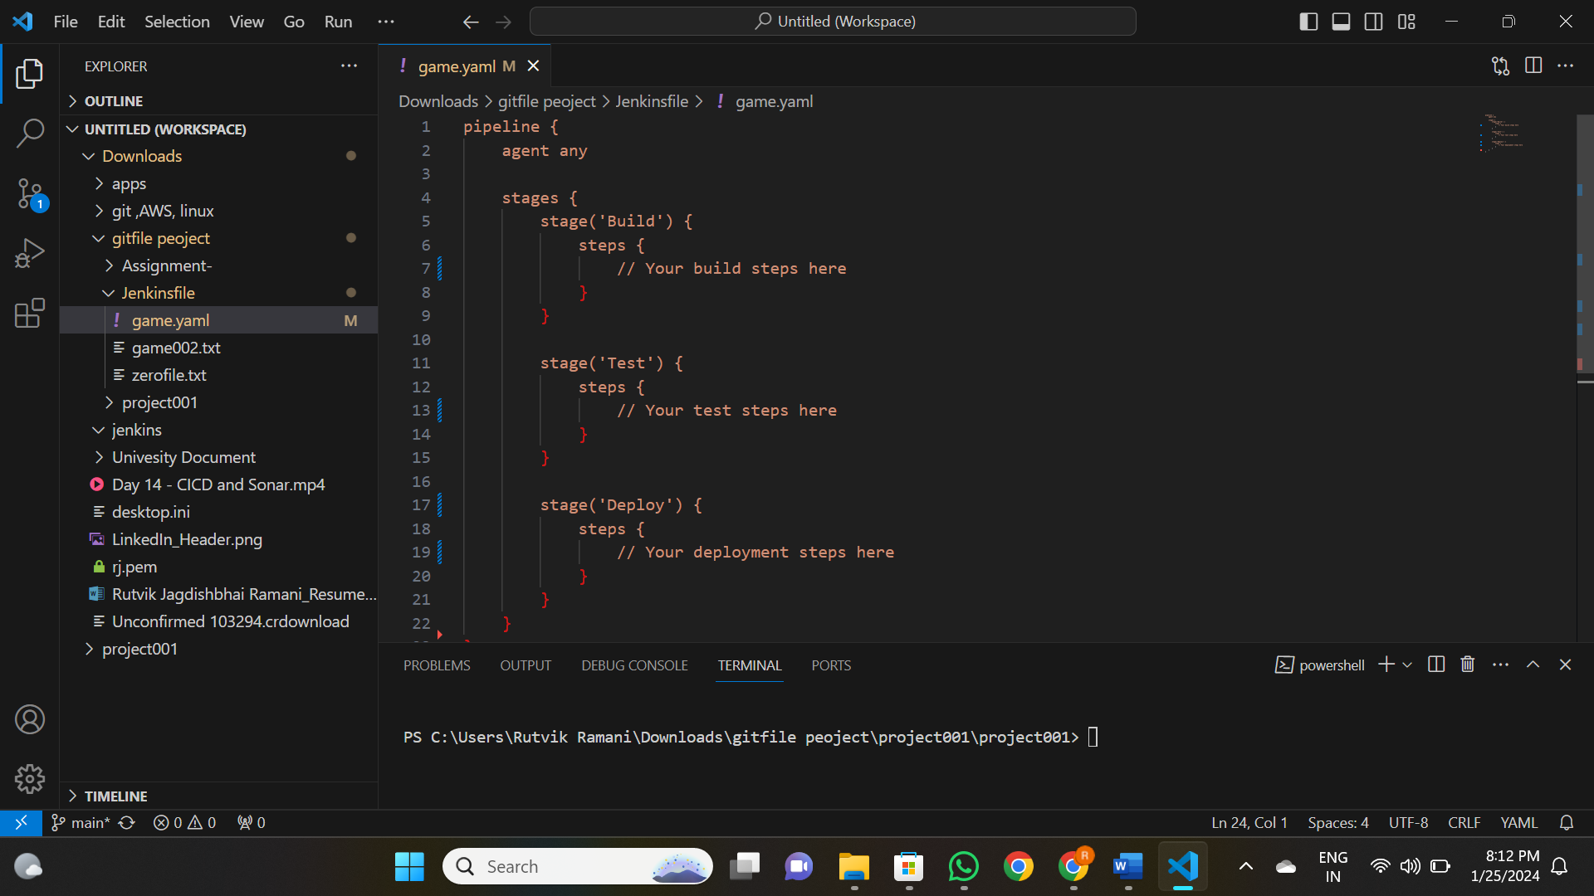**01/25/2024:** CICD and Artifactory

1) Create Freestyle Project with Execute Shell and Build Pipeline

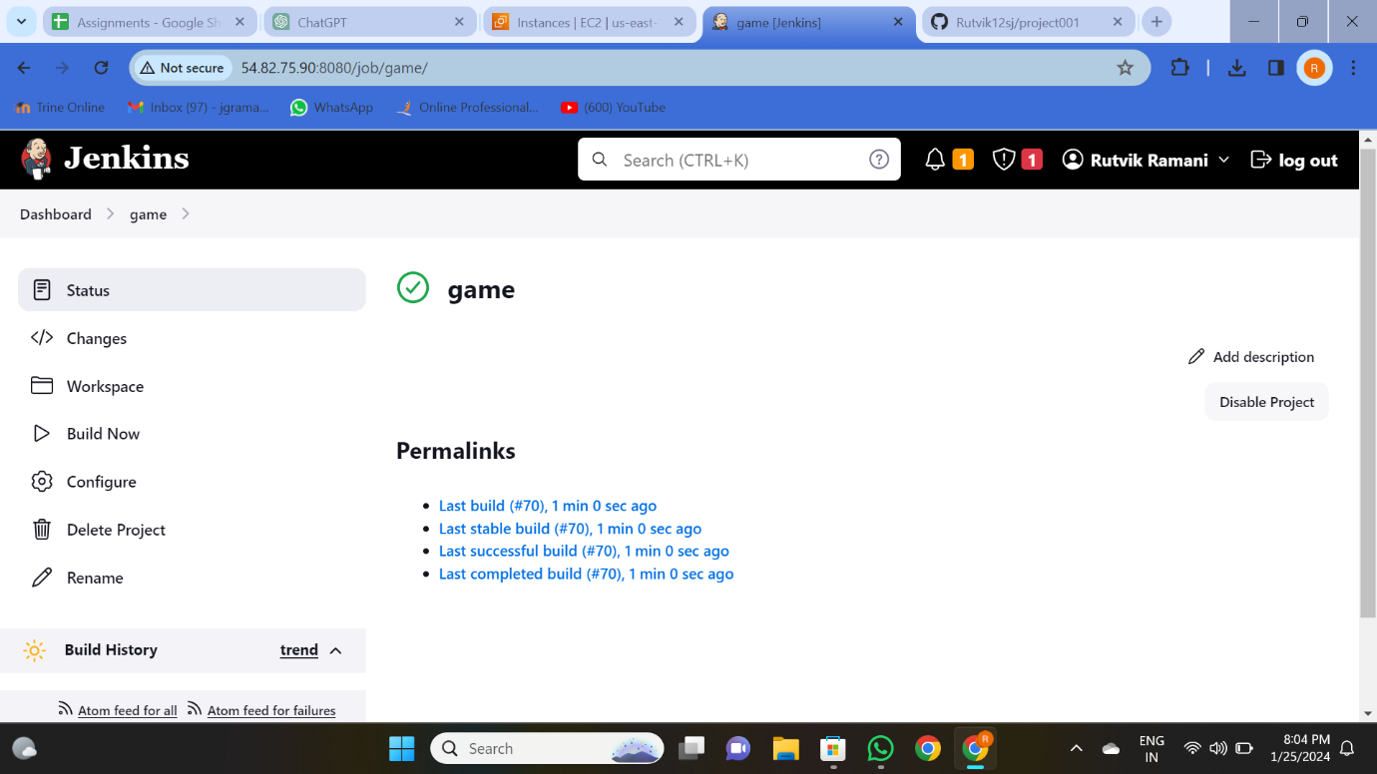2) Create an Azure DevOps Account

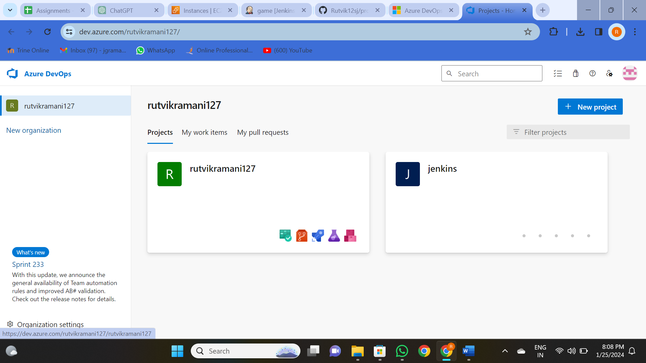

**01/26/2024**: Resume

**01/29/2024:**

1) Create Lambda Function and Integrate with ALB and Launch ALB DNS from Browser

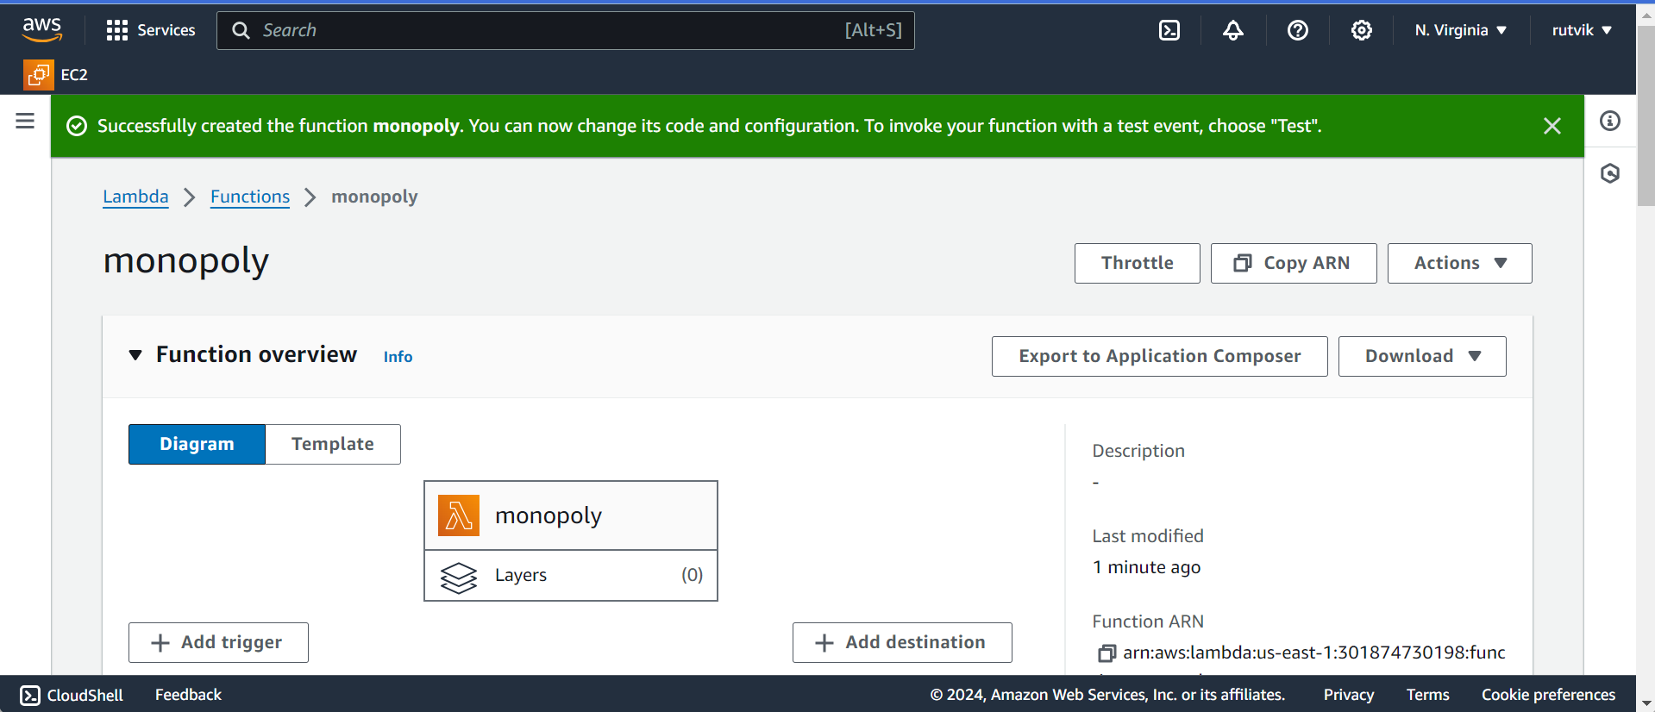

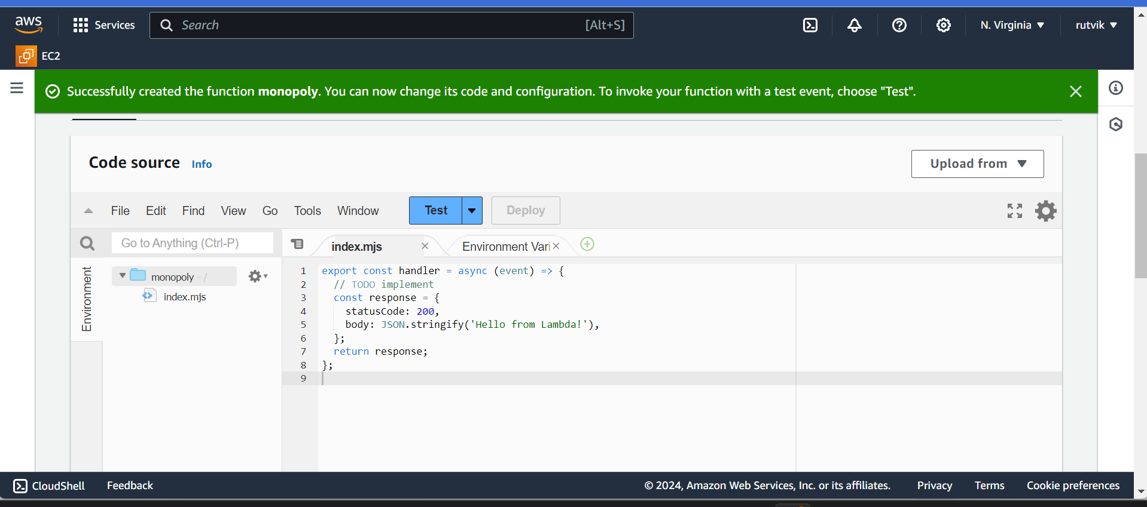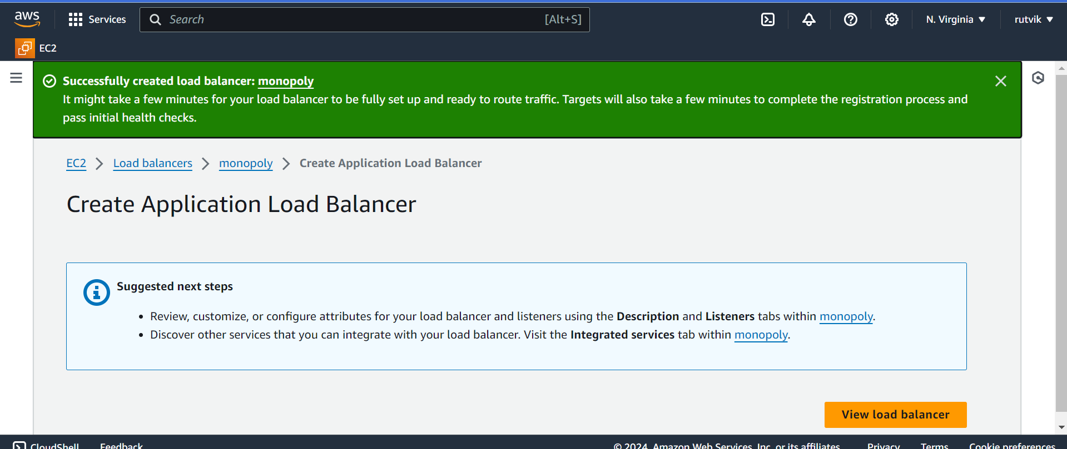

1. Create ElasticBean Stalk and Observe all different components 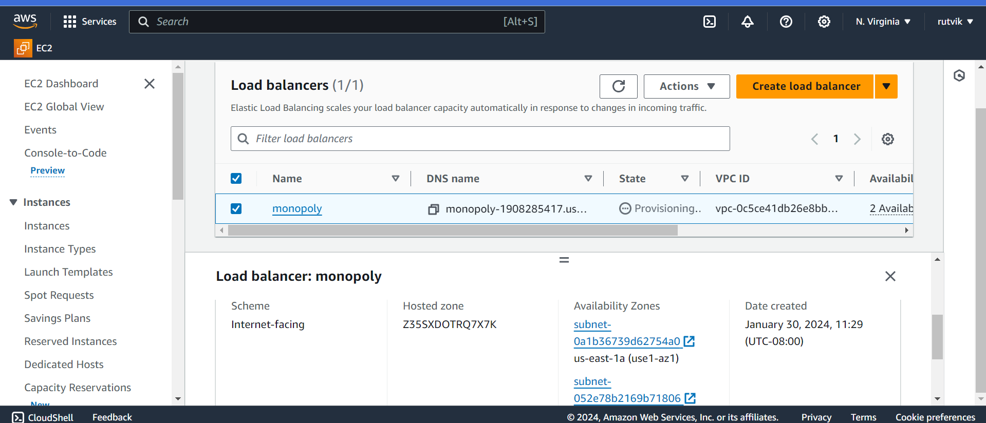
2. Request Azure DevOps Parallelism Request

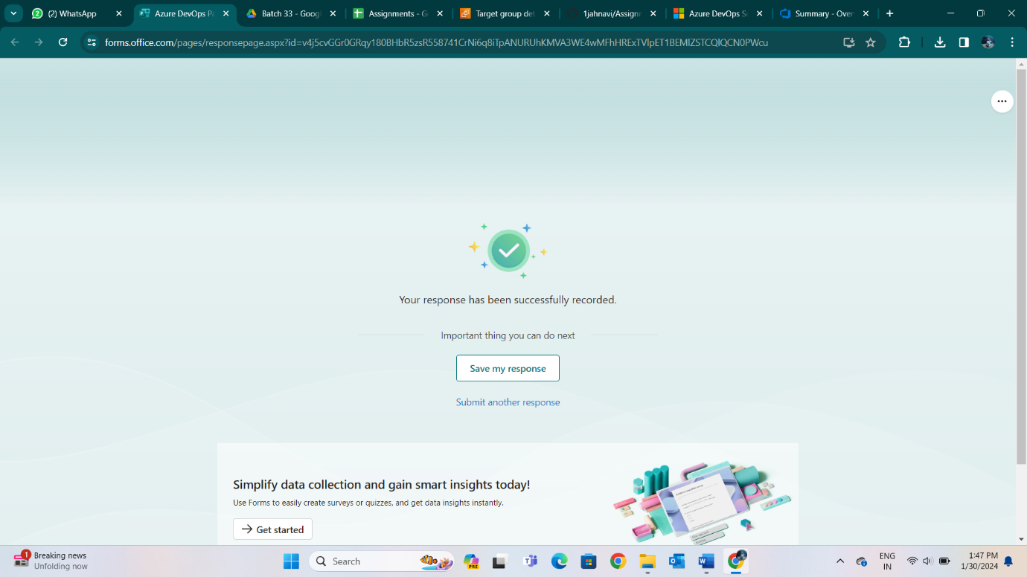

**01/30/2024:** K8s Intro and Microservices IAM Roles

1. Setup Docker

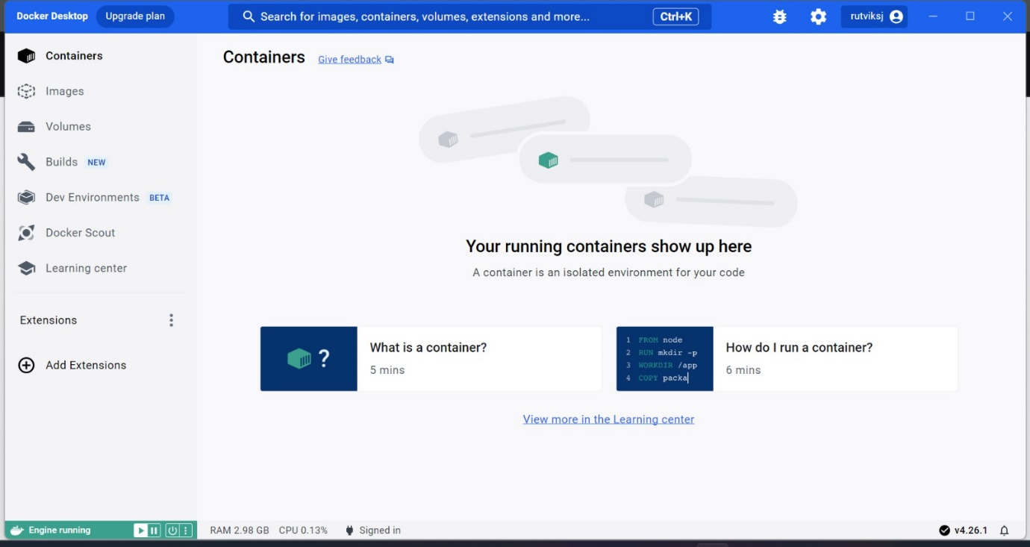

2) Setup IAM Role to copy folder using crontab from ec2 to s3

3) aws cli (aws s3 sync <source> <destination>

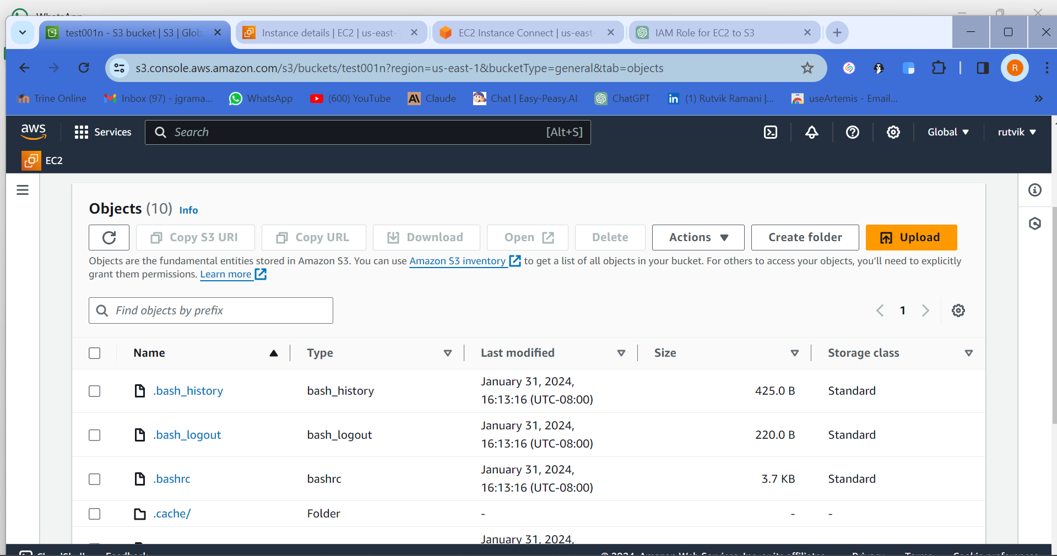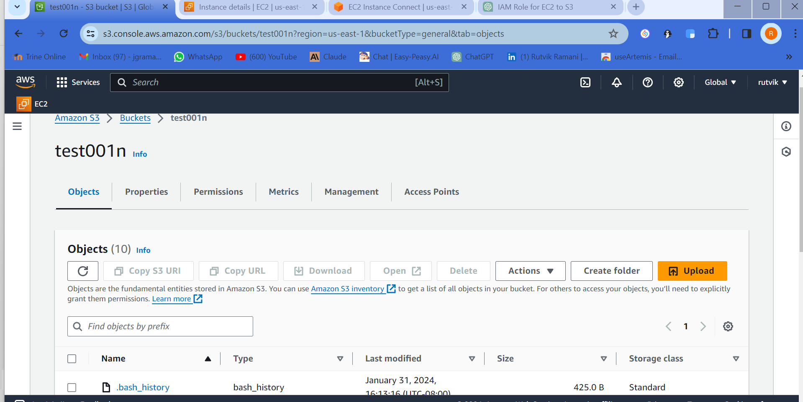

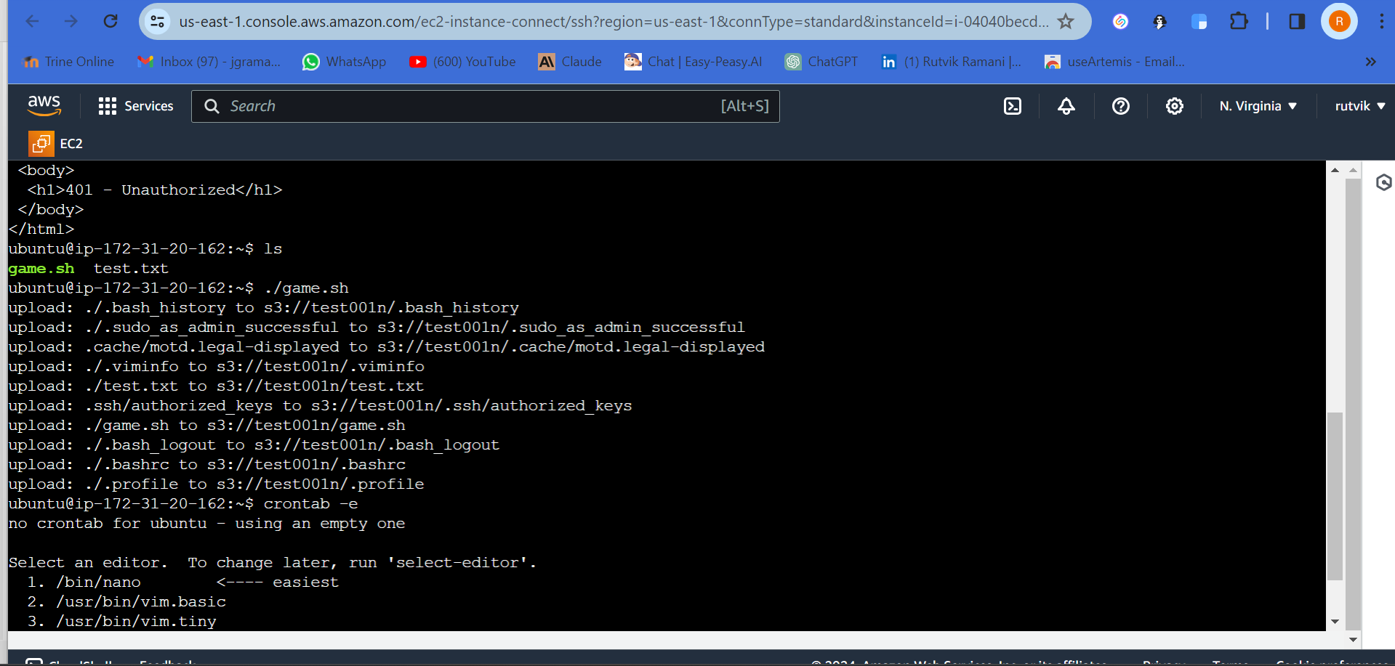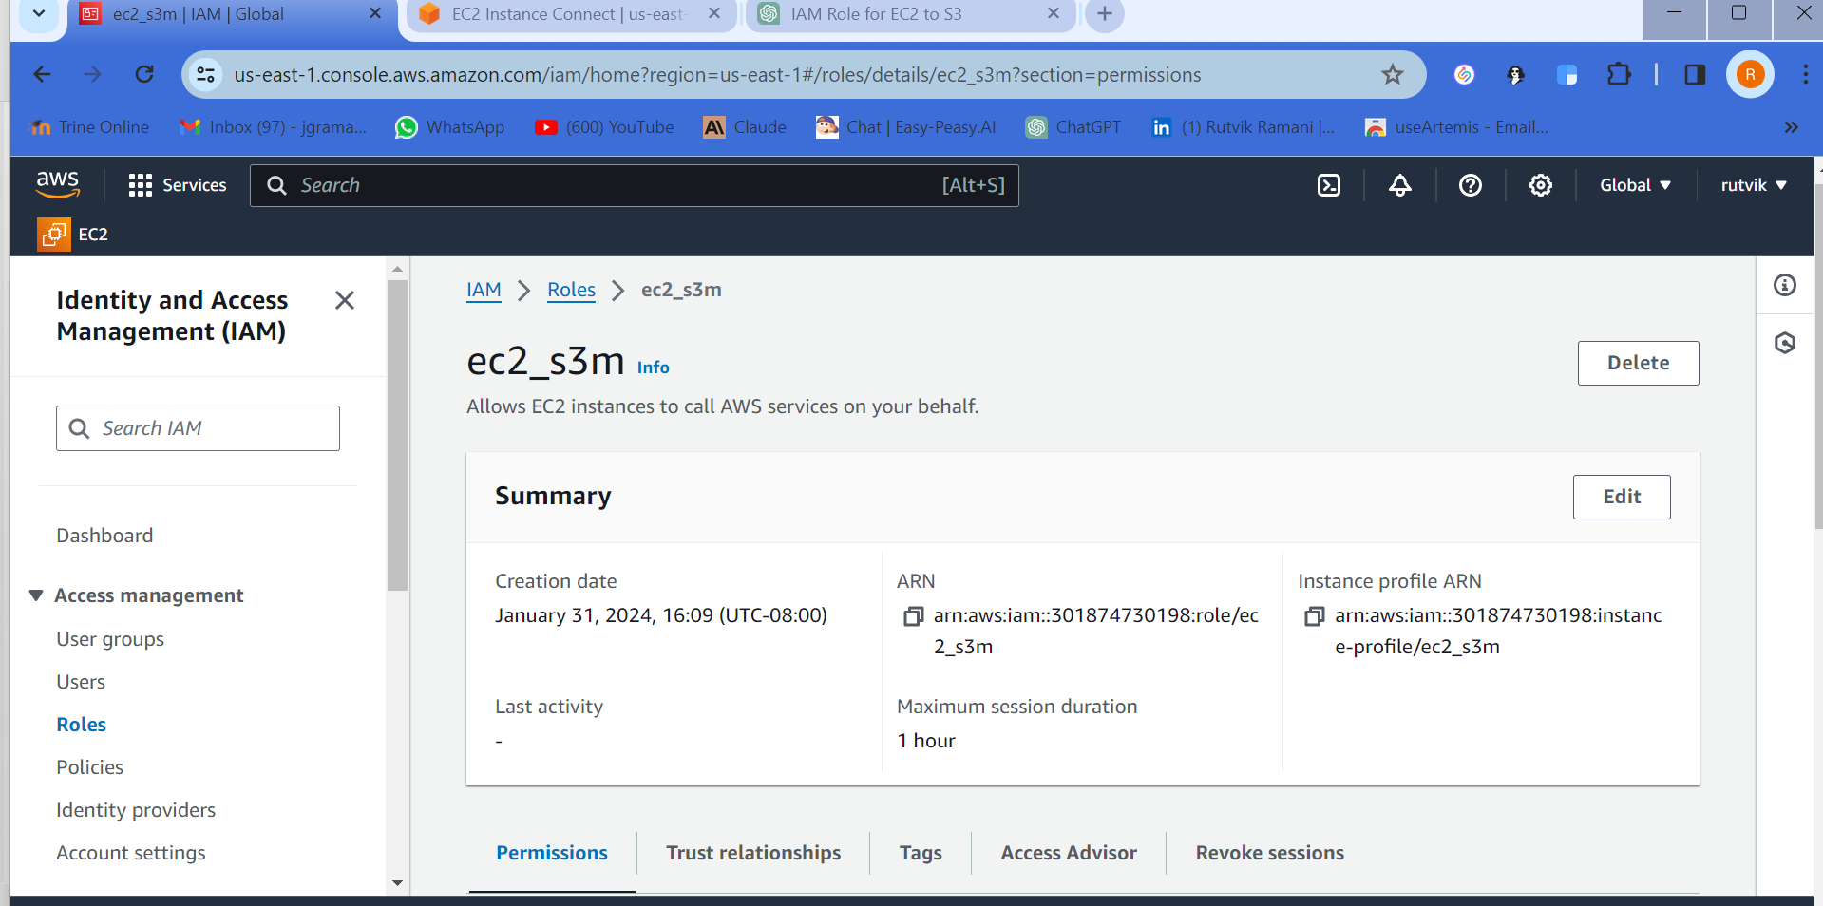

02/01/2024:

1) Clone Repo provided link, build docker and run container

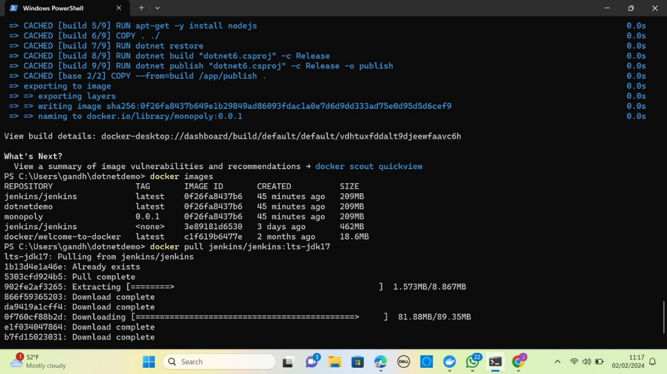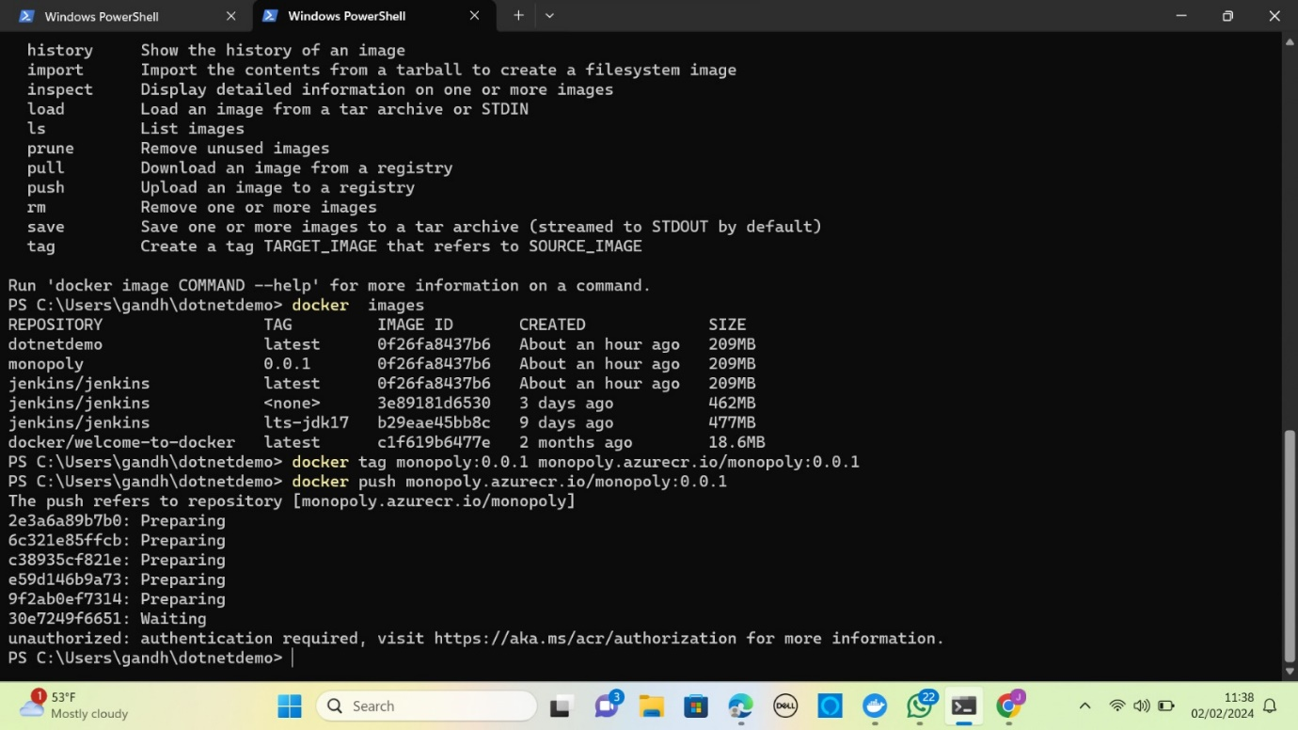

1. ADO Account, Azure Account has to be ready
2. Create ACR and push image to ACR

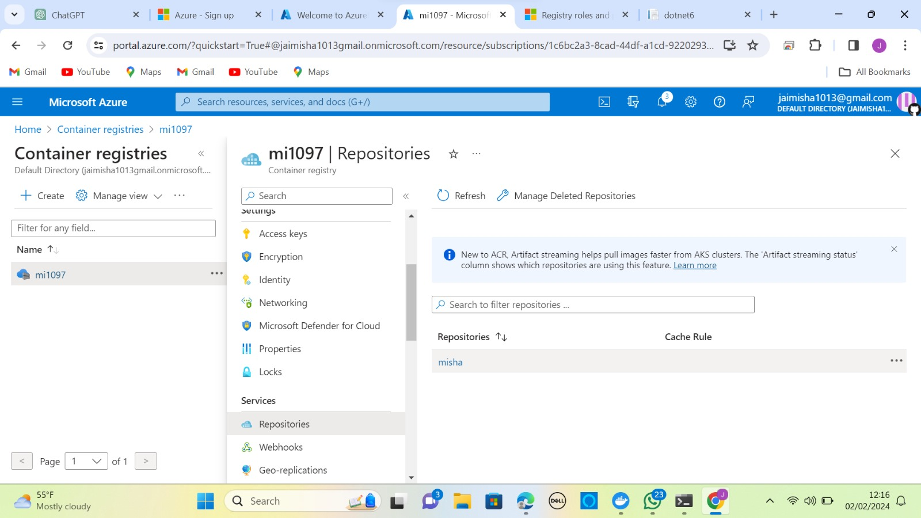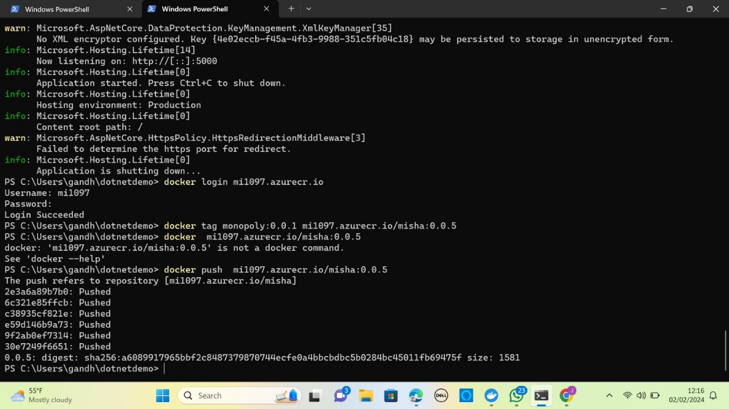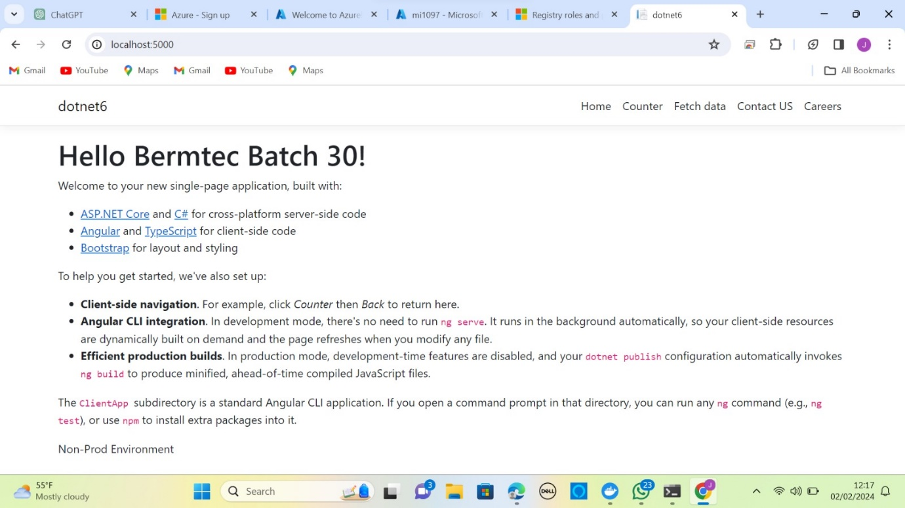

4) GO through Docker Architecture and YAML

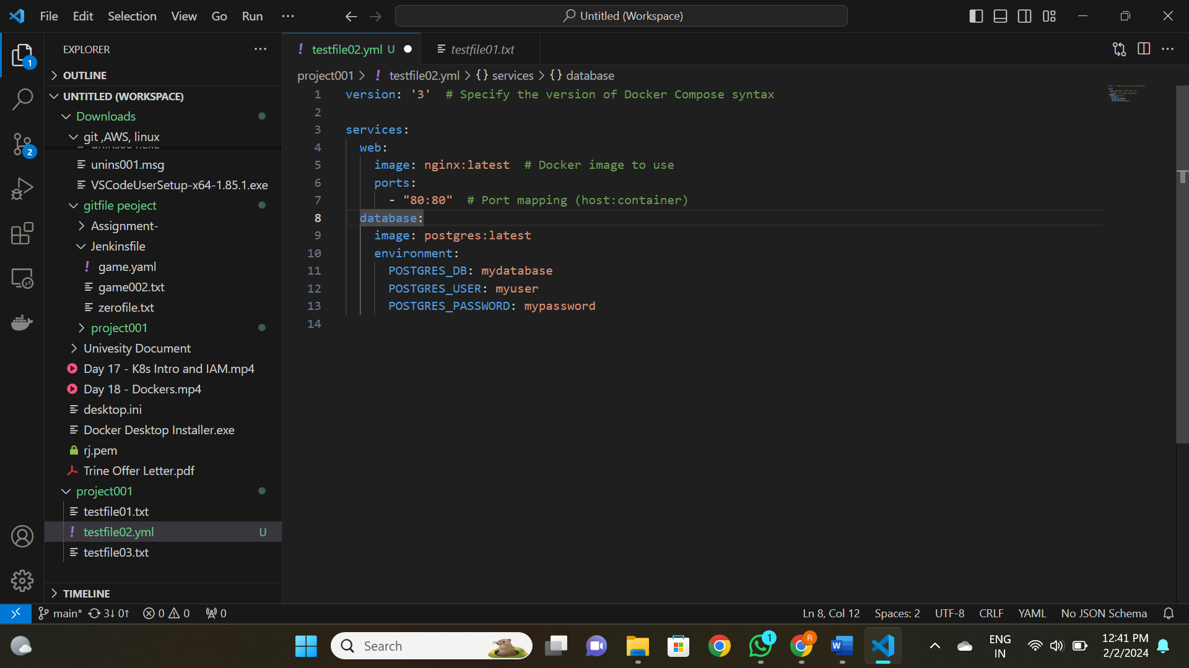

02/02/2024:

1. Create AKS Cluster

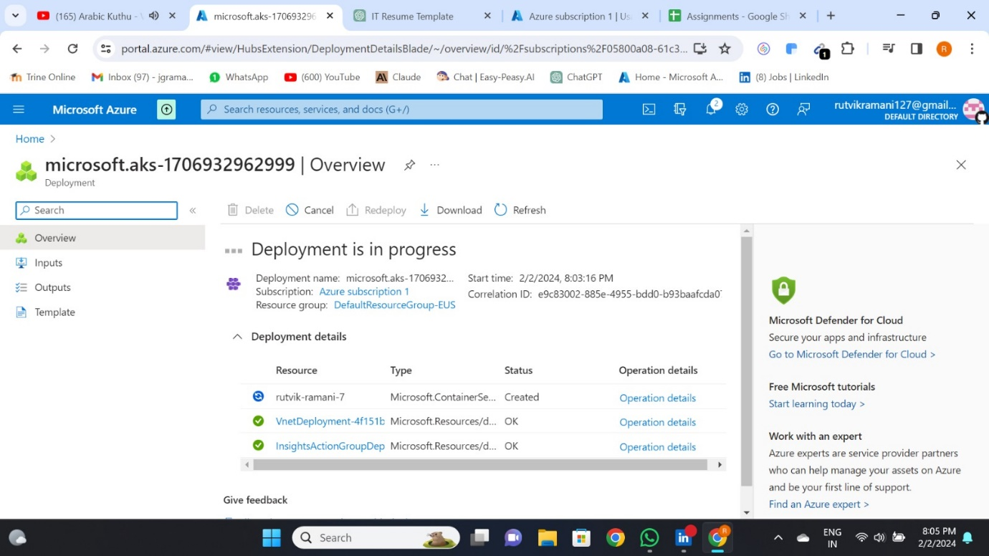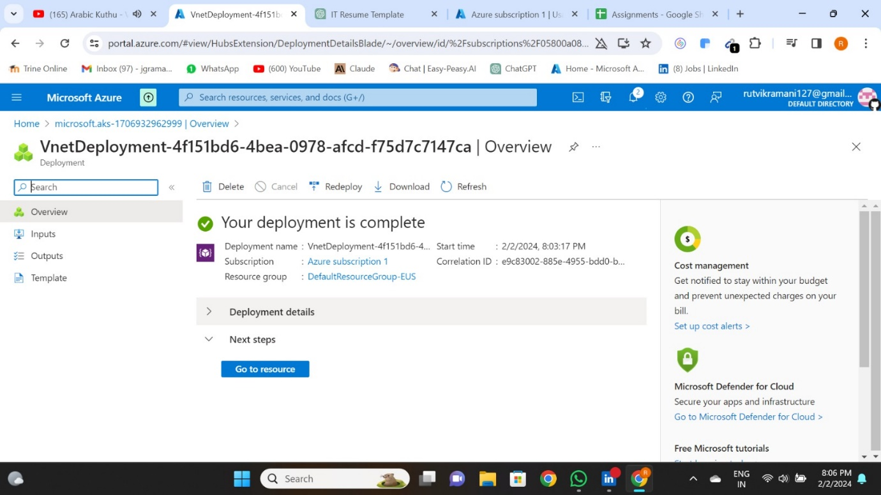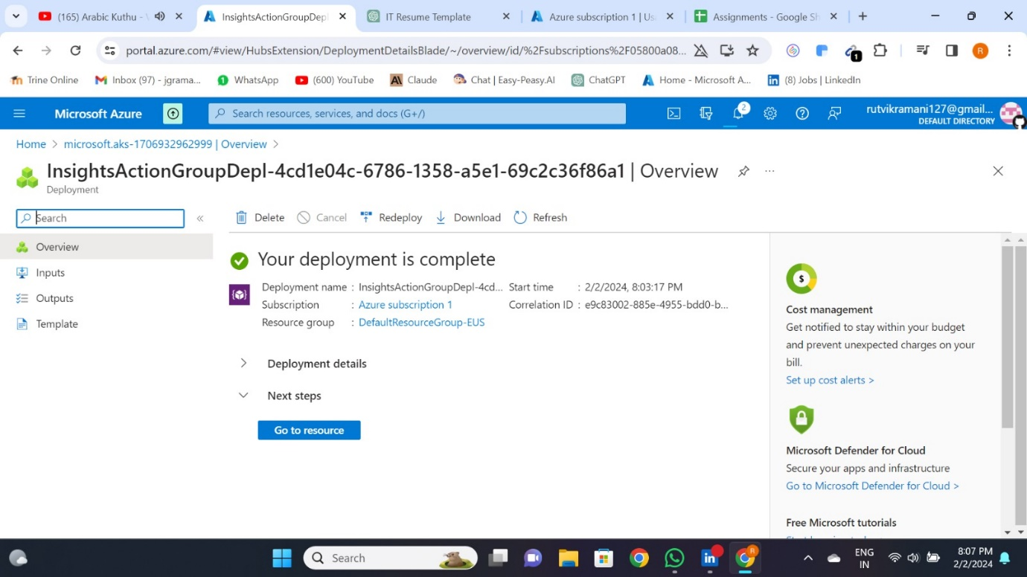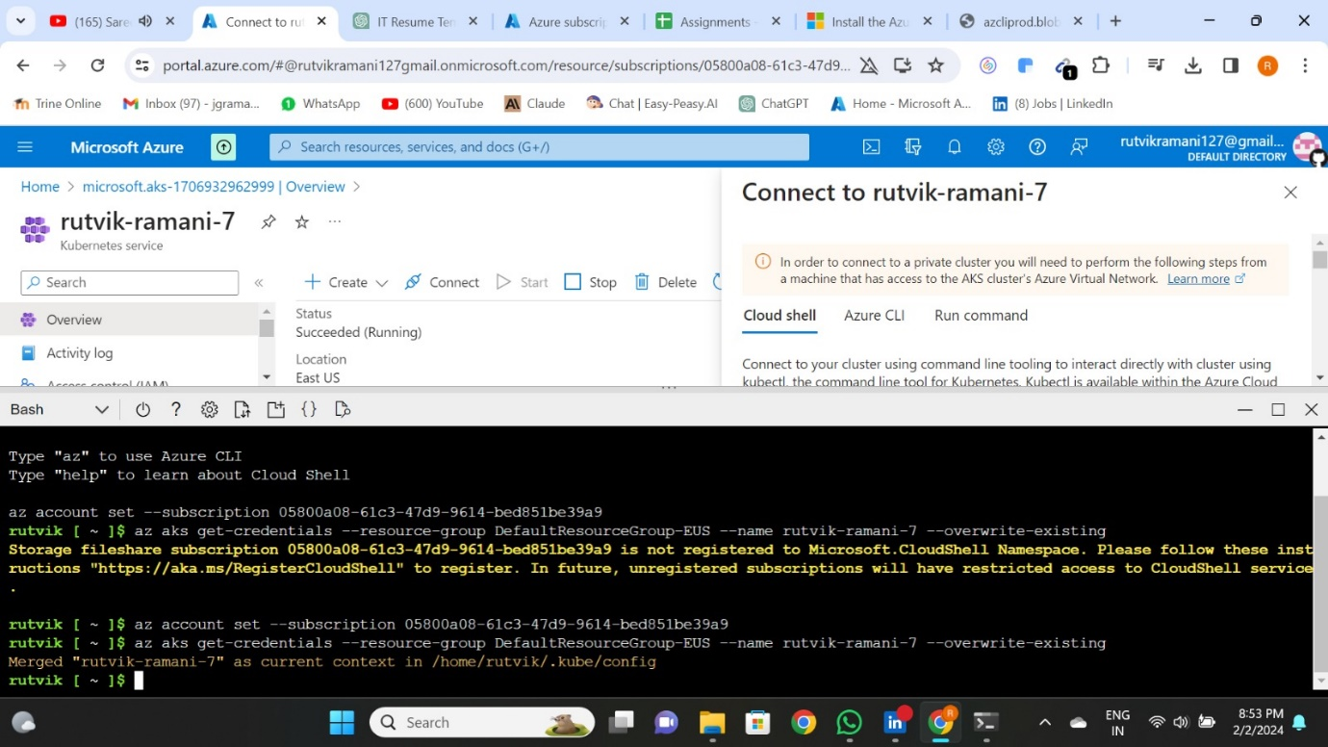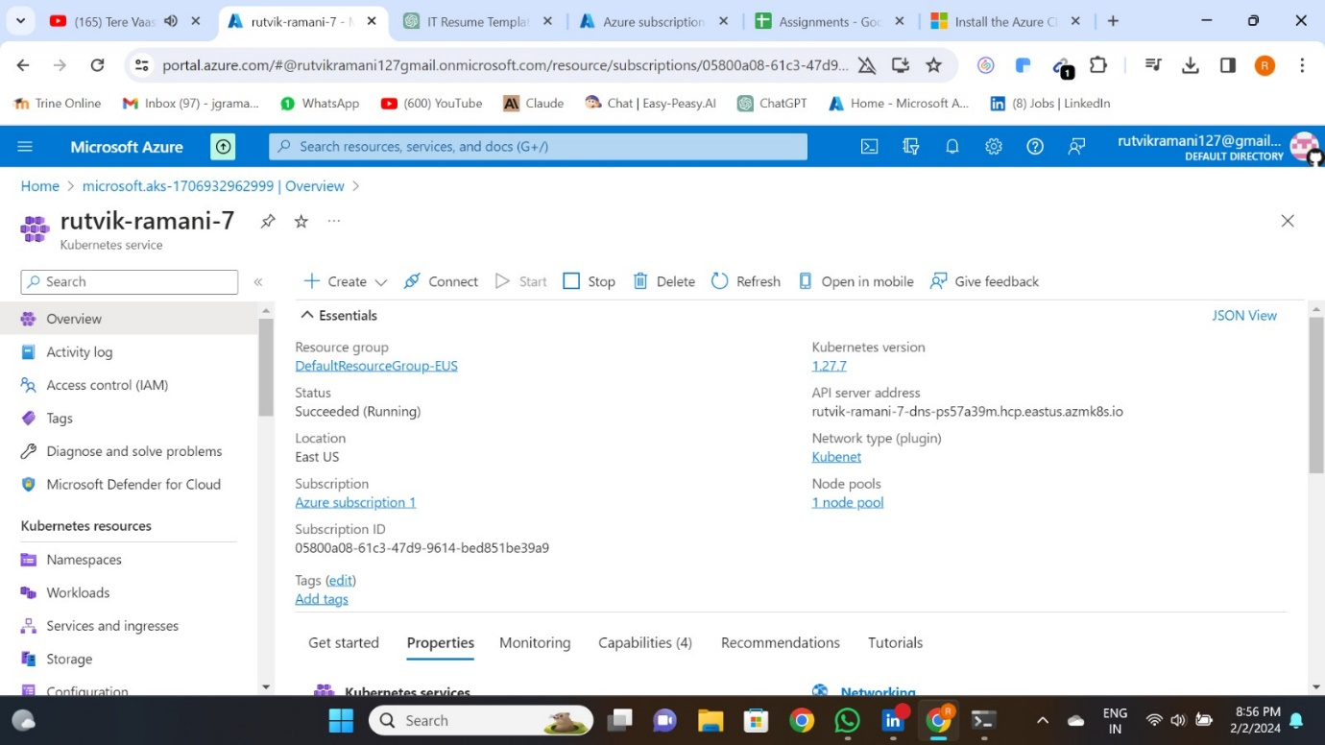

1. Create ADO Classic Build Pipeline (CI)

